AI 900

Contents

AI, ML AND DEEP LEARNING 3

WHAT IS MACHINE LEARNING 3

DEEP LEARNING 4

GENERATIVE AI 5

MACHINE LEARNING MODEL 9

MACHINE LEARNING PROCESS 10

MACHINE LEARNING MODEL AND DATASET 11

DATA SET 11

FEATURES AND LABELS 12

FEATURE ENGINEERING 12

MACHINE LEARNING ALGORITHMS 12

MACHINE LEARNING MODELS 13

MACHINE LEARNING ALGORITHMS CLASSIFICATION 14

AZURE MACHINE LEARNING WORKSPACE 15

CREATING AZURE MACHINE LEARNING WORKSPACE 15

WORKING WITH ML WORKSPACE 18

BUILDING CLASSIFICATION ML PIPELINE 19

STEP 1: SPLIT DATA 20

STEP 2: TRAIN MODEL 26

STEP 3: SCORE MODEL 28

STEP 4: EVALUATE MODEL 29

STEP 5: RUN THE PIPELINE – EXPERIMENT 29

EVALUATION OF MODEL RESULT 29

DEPLOYING THE ML MODEL 31

INFERENCE PIPELINE 32

TESTING THE MODEL 39

CONSUMING MODEL USING ENDPOINT 39

AZURE AI VISION SERVICE 41

CREATING AI VISION SERVICE 42

VISION STUDIO 43

FEATURE - EXTRACT COMMON TAGS FROM IMAGES 44

FEATURE – ADD CAPTION TO IMAGES 46

FEATURE – OBJECT DETECTION 47

FEATURE – OPTICAL CHARACTER RECOGNITION 49

API CALL TO VISION SERVICE – POSTMAN 49

CUSTOM VISION SERVICE 52

SETTING UP CUSTOM VISION SERVICE 53

CREATING A CUSTOM VISION SERVICE 53

CUSTOM VISION PORTAL 55

FACE API 60

NATURAL LANGUAGE PROCESSING 60

SERVICES FOR NLP IN AZURE 60

AZURE LANGUAGE SERVICE 61

CREATING LANGUAGE SERVICE 61

KEY FEATURES 63

KEY PHRASE EXTRACTION 63

AZURE TRANSLATOR SERVICE 63

AZURE SPEECH SERVICE 63

# AI, ML AND DEEP LEARNING

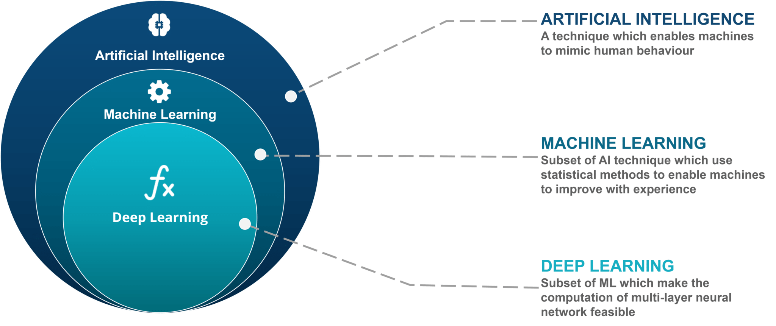

# WHAT IS MACHINE LEARNING

* Machine learning is a subfield of artificial intelligence.
* It involves training computers on large amounts of data.
* Computers learn from the data and make predictions or decisions.
* It allows computers to recognize patterns and improve their performance over time.
* Machine learning is used in various applications like image and speech recognition, recommendation systems, and predictive analytics.

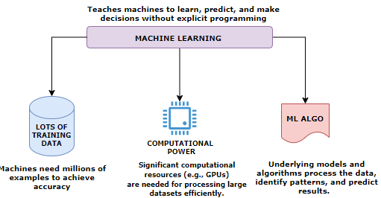

### DEEP LEARNING

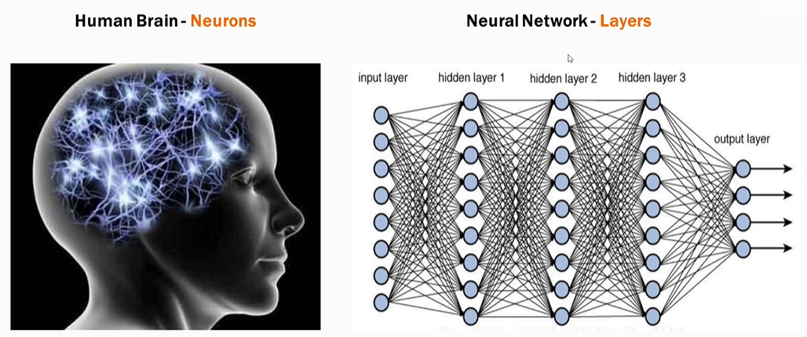

* Deep learning is a subset of Machine Learning based on neural networks which mimic the structure of human neurons.
* Neural networks consist of multiple computational layers.
* Each layer processes and enhances the data before passing it to the next layer.
* This multi-layer structure improves accuracy for complex tasks (e.g., text generation, image generation).
* *Neural network is the model that generative tools like ChatGPT are also using*.

#### ADVANTAGES OF DEEP LEARNING

* **Higher Accuracy**: Suitable for solving complex problems.
* **Generative AI Application**: Tools like ChatGPT use deep learning neural networks to enhance text generation accuracy.
* **Utilization of GPUs**: Recent advancements in computational power have made deep learning models more accessible and efficient.

### GENERATIVE AI

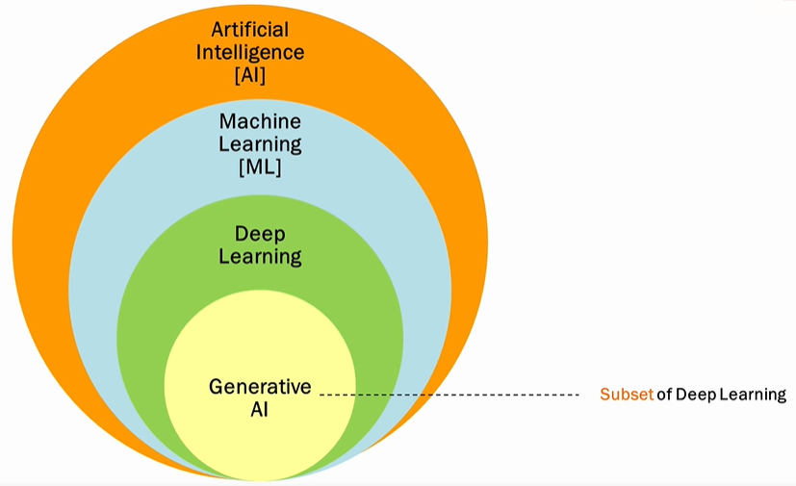

* **Deep Learning is a subset of that uses neural networks to generate new content like text, images, videos, or audio.**
* **Unlike conventional AI, Generative AI doesn't just classify or predict data; it generates brand-new content based on its training data.**

#### CONVENTIONAL AI VERSUS GENERATIVE AI

**CONVENTIONAL AI**

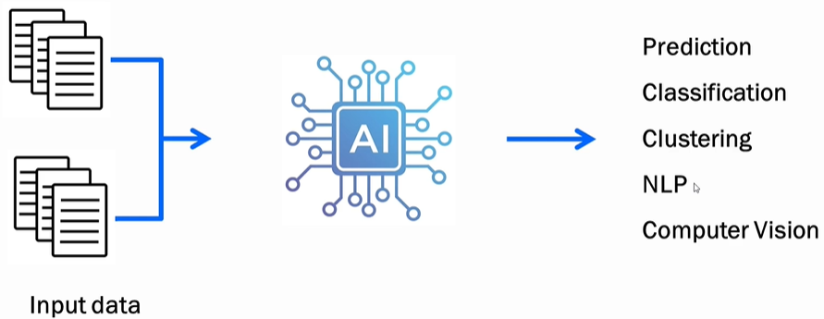

* Operates by learning from training data and making predictions, classifications, or performing language processing/computer vision.
* Example: Trained on apple images, it tells whether a supplied image is of an apple.

**GENERATIVE AI**

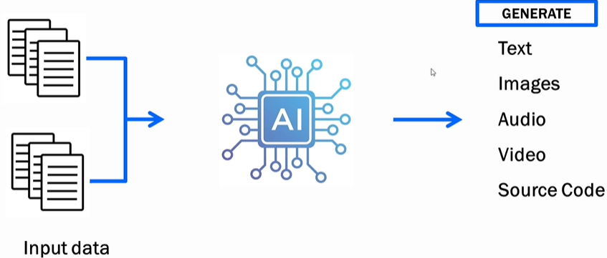

* Learns from training data and creates *new* content.
* Example: Trained on apple images, it generates a new apple image not extracted from the training data.

#### KEY TEMINOLOGIES

##### =LARGE LANGUAGE MODEL

* LLMs are AI models designed to understand and generate human-like text.
* Unlike general generative AI (which handles text, images, audio, video, etc.), **LLMs deal exclusively with text—words, grammar, sentences, and contextual understanding.** Example: ChatGPT is a strong example of an LLM.

###### HOW LLMS WORK

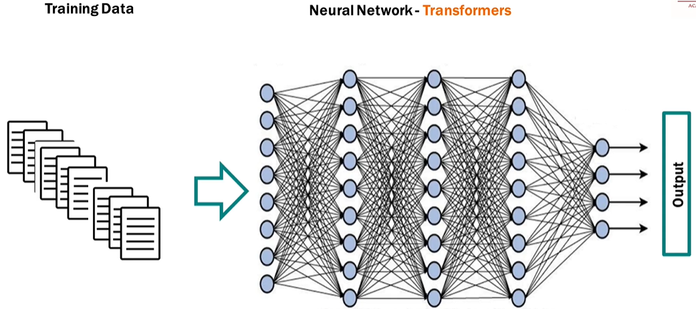

* **NEURAL NETWORKS**:
  + LLMs use **transformers**, which are specialized neural networks designed to understand language, meaning, and context.
  + Transformers enable LLMs to process and generate text efficiently.
* **TRAINING**:
  + LLMs are trained on vast amounts of text data (e.g., Wikipedia, blogs, websites) and learn patterns, semantics, and context.
  + GPT-3, for instance, was trained on over **500GB of data** and used **175 billion parameters**; Google’s PaLM has **540 billion parameters**.
  + Training is crucial—larger datasets and more parameters improve accuracy and performance.
* **SEQUENTIAL WORD PREDICTION**:
  + LLMs generate output one word at a time, predicting the next word in sequence, resulting in sentences and paragraphs.

##### EMBEDDINGS IN GENERATIVE AI

* Embeddings are numerical representations of text—a way to convert words into numbers so machines can understand and process them.
* Machines do not inherently understand text; they operate using numbers. Embeddings allow machine learning models to interpret meaning, context, and relationships between words.

**KEY FUNCTIONALITY OF EMBEDDINGS**

1. **CAPTURING MEANING**: Embeddings reflect the semantic meaning of words or sentences.
2. **CONTEXT UNDERSTANDING**: Embeddings account for the context of text (e.g., same word in different sentences/sentiments - “great” in sarcasm vs happiness).

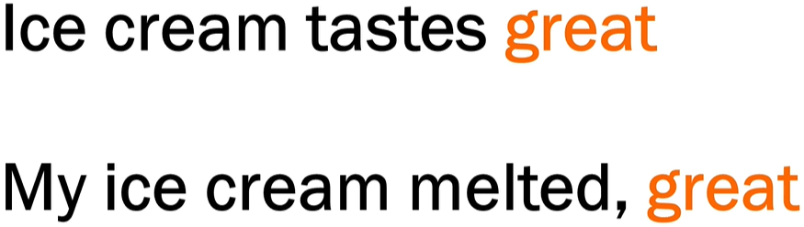

1. **RELATIONSHIPS**:

* Words with strong associations (e.g., "ice" and "cream") have similar embeddings, reflecting their connection.
* Models understand the proximity and sequence of words based on embeddings.

**HOW EMBEDDINGS ARE GENERATED**

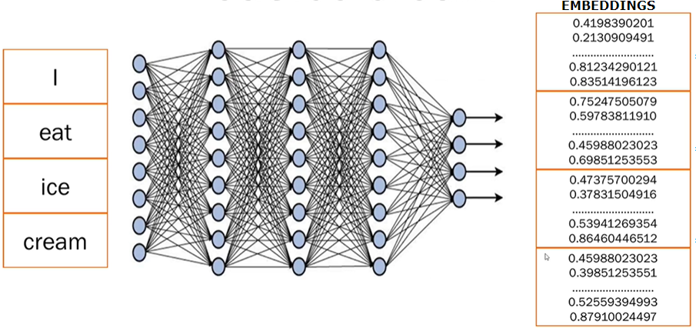

1. **STEP 1:** **BREAKING TEXT INTO TOKENS**

* Sentences are broken into smaller pieces or tokens (e.g., splitting "I eat ice cream" into 4 tokens—"I", "eat", "ice", "cream").

2. **STEP 2: NEURAL NETWORK PROCESSING**:

* Trained **transformer models** (like those behind ChatGPT) analyze the text, generate embeddings, and capture meaning, context, and relations between tokens.

1. **STEP 3: NUMERICAL EMBEDDINGS:**

* Each token is converted into numerical data (random numbers).
* These numbers represent embeddings, storing all learned information about the word or sentence.
* Only the transformer model understands what these embeddings mean based on its training.

##### FINE TUNING

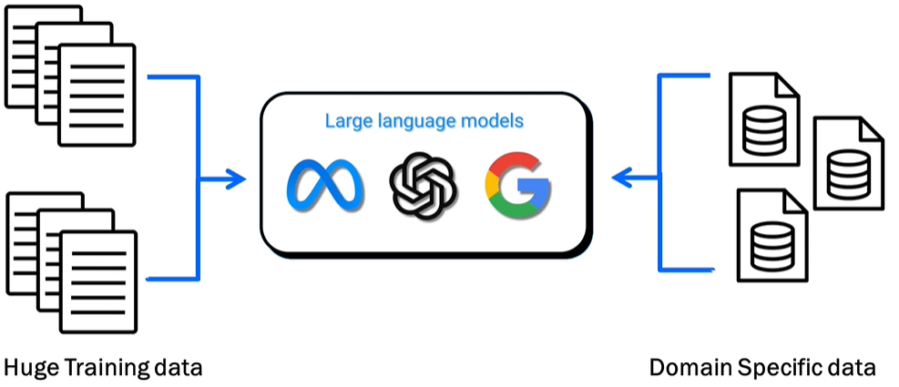

WHAT IS FINE TUNING

* Adjusting a pre-trained large language model (LLM) to provide better results on specific tasks or domain-specific datasets (e.g., healthcare, finance, etc.).

WHAT IS THE PURPOSE OF FINE TUNING

* Enhance the model's ability to generate focused and precise results on specialized datasets.
* Example: Fine-tuning an LLM on medical data improves its accuracy in answering medical queries compared to a general-purpose/pre-trained model.

###### DIFFERENT WAYS TO FINE TUNNING A MODEL

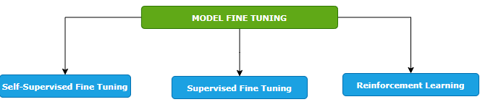

SELF-SUPERVISED FINE TUNING

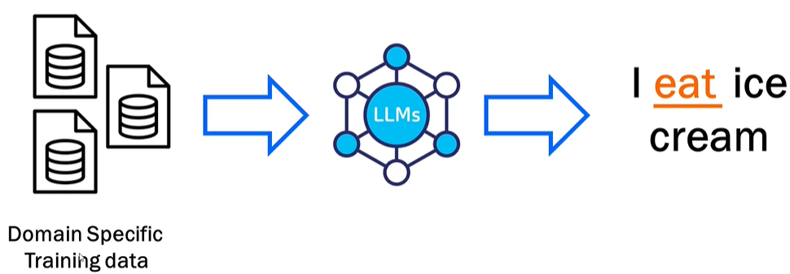

* Training the model on a domain-specific dataset. Means – we give the foundation model a big pile of training data that is specific to our domain, and the model will learn from it. In this way, the model learns to predict missing pieces of data.
* Example - when we say I ice cream, the model predicts that the missing word is eat.
* This is like how the foundation model is trained but the key difference here is that we are fine tuning the model by providing the domain specific data set. Example - Like if we want to train it on health care data set, we will pass it - the drug structure, scientific studies, all the documents that are related to drug and the model will learn from it and it would be able to generate content based on that.

SUPERVISED FINE TUNING

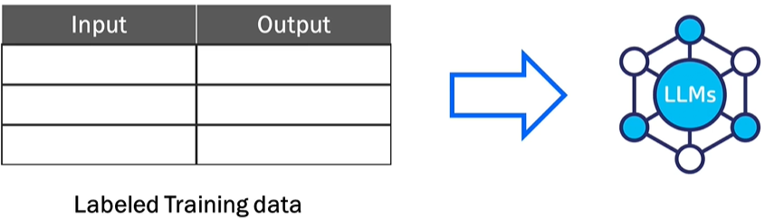

* The model is trained using a labeled dataset where both inputs and outputs are provided.
* Example: Input: "How do I find a broken bone?" → Output: "X-ray."
* Helps the model learn more precise responses based on labeled data.

REINFORCEMENT LEARNING

|  |  |
| --- | --- |
|  |  |
| **LOW SCORE FOR BAD RESULT** | **HIGH SCORE FOR GOOD RESULTS** |

* **Feedback-based learning**.
* The model generates outputs, and scores are assigned based on quality (high score for good results, low score for bad results).
* The model learns over time from the feedback to improve predictions.

##### KEY FEATURES OF FINE TUNING

1. **STARTS FROM A PRE-TRAINED MODEL**: Fine tuning builds on top of a foundation model already trained on large datasets—it does not start from scratch.
2. **REQUIRES DOMAIN-SPECIFIC DATA**: We must provide good-quality, specific data for training tailored to your use case (e.g., drug data for healthcare).
3. **No Universal SOLUTION**: Each task/use case is unique, requiring case-specific implementation and variations.
4. **ITERATIVE PROCESS**: Fine tuning is repetitive and requires multiple cycles of iteration and adjustments for optimal results.

## MACHINE LEARNING MODEL

* This is an object that has been trained beforehand on a dataset. The model can then give output based on input values
* The machine learning object is nothing but a file or set of files. It would have the desired logic that would take in input and spur output data

## MACHINE LEARNING PROCESS

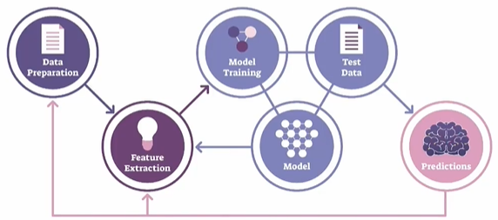

1. **DATA PREPARATION**:
   1. This step involves gathering and cleaning the data to make it suitable for analysis.
   2. It includes tasks like handling missing values, removing outliers, normalizing or standardizing the data, and splitting the data into training and testing sets.
2. **FEATURE EXTRACTION**:
   1. Feature extraction is the process of selecting or creating relevant features from the data that will be used as input for the machine learning model.
   2. It involves identifying the most informative attributes or transforming the data into a more meaningful representation that captures the underlying patterns and relationships.
3. **MODEL TRAINING**:
   1. Model training is the process of using the prepared dataset to teach the machine learning model to recognize patterns and make predictions.
   2. During this step, the model learns from the input data and adjusts its internal parameters to optimize its performance.
4. **MODEL**:
   1. The model is the representation of the learned patterns and relationships from the training data.
   2. It encapsulates the knowledge gained during the training process and can be used to make predictions or decisions on new, unseen data.
5. **TEST DATA**:
   1. Test data is a separate set of data that is not used during the model training. It is used to evaluate the performance of the trained model and measure its accuracy.
   2. The test data should be representative of the real-world scenarios the model will encounter.
6. **PREDICTION**:
   1. Once the model is trained and evaluated, it can be used to make predictions on new, unseen data.
   2. The model takes the input data, processes it using the learned patterns, and generates predictions or decisions based on the trained knowledge.
   3. The accuracy and reliability of the predictions depend on the quality of the model and the suitability of the input data.

## MACHINE LEARNING MODEL AND DATASET

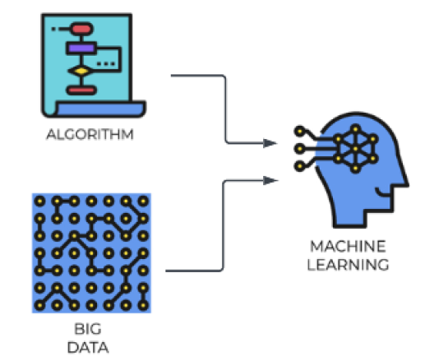

### DATA SET

* A dataset is a collection of structured or unstructured data that is used for analysis, machine learning, or other data-related tasks. It typically consists of multiple data points or instances, where each data point represents an observation or sample.
* A dataset can include various types of data such as numerical, categorical, text, images, or time series.
* Datasets are crucial for training and evaluating machine learning models. They provide the necessary information for the model to learn patterns and relationships.
* Datasets can be sourced from various places, including public repositories, research institutions, or generated internally within an organization
* Common operations on datasets include cleaning, transforming, splitting into training and testing sets, and feature engineering.

#### EXAMPLE

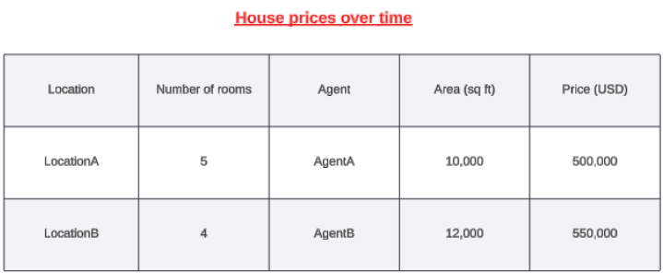

* Let's say we are building a ML model that can predict the house prices over time. For that we need to have prior information in place about the houses that were already sold over the previous years.
* The information can be the location of the house, the number of rooms, the agent involved in selling the house,

the area in square feet, and what was the price in USD. (as shown in above table)

* To train the model using historical data, we need to select the relevant features/column. ( for example, Agent column is irrelevant for price prediction)
* **This is the historical data is then used to training the ML model. Hence the data like - location, the number of rooms, and the area will become the features. Features are the measurable property within the dataset and the price is going be the label.**

### FEATURES AND LABELS

#### FEATURES

* Features, also known as input variables or independent variables, are the measurable properties or characteristics of the data that are used to make predictions or classifications.
* They represent the input data that the model will analyze and learn patterns from. For example, in the context of predicting house prices, features could include the location, number of rooms, and area of a house.
* Each feature is represented by a specific value or attribute.

#### LABELS

* Labels, also known as target variables or dependent variables, are the values that the model aims to predict or classify.
* Labels represent the desired output or outcome based on the input data. In the house price prediction example, the label would be the actual price of the house.
* The model analyzes the provided features and attempts to learn the patterns that will help predict or estimate the label.

|  |
| --- |
| * During the training process, the model is presented with a dataset that contains both the features and the corresponding labels. * The model learns the relationship between the features and labels by adjusting its internal parameters to minimize the difference between its predicted output and the actual labels. * Once trained, the model can then be used to make predictions or classifications on new, unseen data by analyzing the features and producing a predicted label. * In summary, features are the measurable properties of the data that serve as input for the model, while labels are the desired output or outcome that the model aims to predict or classify. The relationship between the features and labels is learned by the model during the training process. |

**IN A NUTSHELL, the summary is**

|  |
| --- |
| * Building a model to predict house prices over time * Prior information about sold houses including location, number of rooms, agent, area, and price in USD * Training the model using historical data, selecting relevant features and the price as the label * Cleaning the data, removing missing values, and performing feature engineering * Splitting the dataset into training and testing sets, using the training set to train the model and the testing set to evaluate its accuracy * Testing the accuracy and precision of the model by comparing its predictions with the actual values * Deploying the model and allowing users to make predictions based on new input data, such as location, number of rooms, and area. |

### FEATURE ENGINEERING

### MACHINE LEARNING ALGORITHMS

|  |  |
| --- | --- |
|  | * When building a machine learning model, we need to train it on a dataset that consists of input features (also known as independent variables) and corresponding output labels (also known as dependent variables). The dataset serves as the training data for the model to learn patterns and relationships between the input features and output labels. * To enable the model to learn from the dataset, we need to choose and apply a suitable machine learning algorithm. These algorithms are designed to process the input features and labels and make predictions or classifications based on the patterns they discover in the data. * The chosen algorithm takes the dataset as input and applies its specific mathematical or statistical techniques to train the model. It learns from the provided dataset by adjusting its internal parameters to minimize the difference between the predicted output and the actual output labels. * Once the model has been trained using the chosen algorithm, it can be used to make predictions or classifications on new, unseen data. The trained model has learned the patterns in the dataset and can apply this knowledge to make predictions on similar data instances. |

### MACHINE LEARNING MODELS

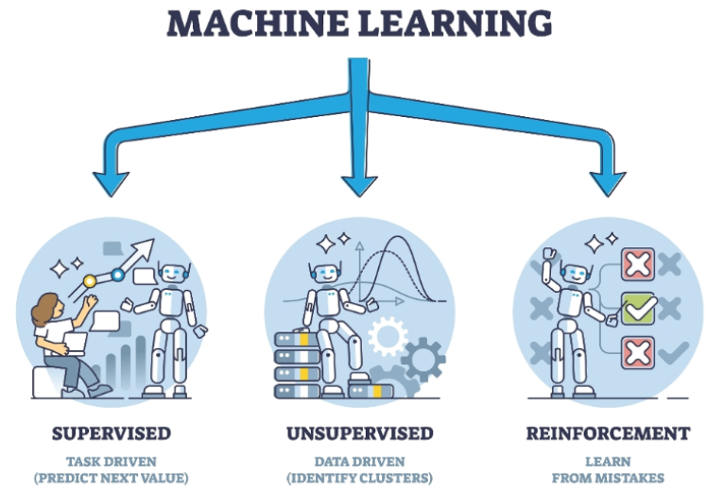

1. **SUPERVISED LEARNING MODELS**
   1. In supervised learning, for training data set that we feed in the features along with the labels(output)
2. **UNSUPERVISED LEARNING MODELS**:
   1. In unsupervised learning – we don’t know what the output will be, hence we cannot provide labels in training data
   2. Here we just want to the model to split our data into different groups or cluster
3. **REINFORCEMENT LEARNING MODELS**:
   1. These models learn through interaction with an environment. They receive feedback in the form of rewards or penalties, allowing them to learn optimal strategies for decision-making.
   2. Example :
      1. Let's take the example where we trying to teach a system how to play a game of chess against a human. So now, instead of we feeding in data about the different chess moves, we ask the model to play against a human.
      2. Hence, the system would go ahead and make a set of moves, and let's say it loses. So now it understands that if it performs particular set of actions, it results in a loss,then the next time around it will go and change its actions.
      3. It'll keep on doing this, so it's performing reinforcement of its actions. At the end when it does actually win a game,that's the reward. So now it understands that based on certain set of actions that it takes, it's gonna get a reward.

### MACHINE LEARNING ALGORITHMS CLASSIFICATION

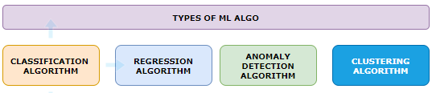

#### CLASSIFICATION ALGORITHM

* This is simply used to class the data
* Example: Will the customer purchase the new product – Simple “yes”/ “No” answer

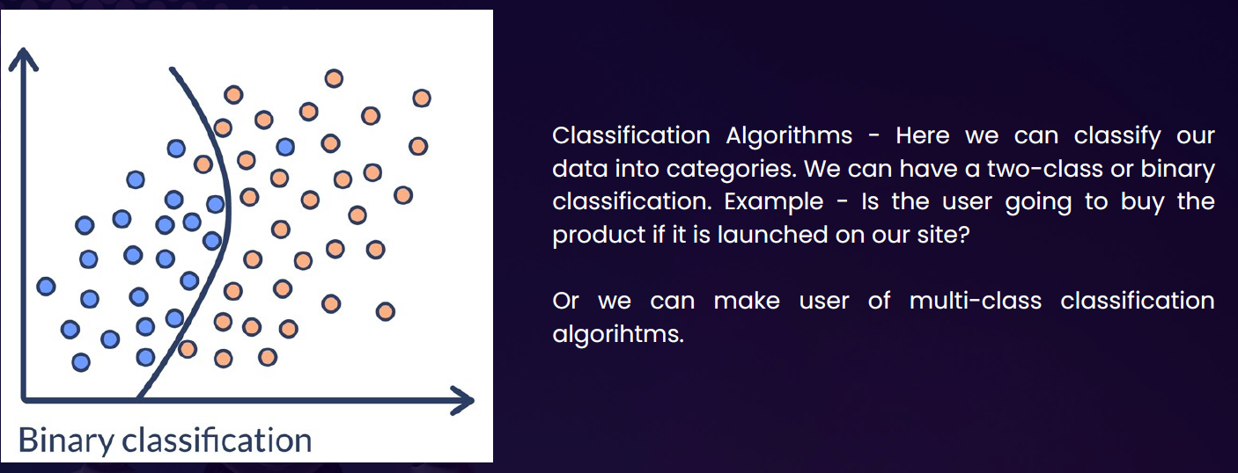

#### REGRESSION ALGORITHM

* This is used to predict new data point based on historical data
* Example: Calculate the forecasted revenue of a new product over coming week based on historical data

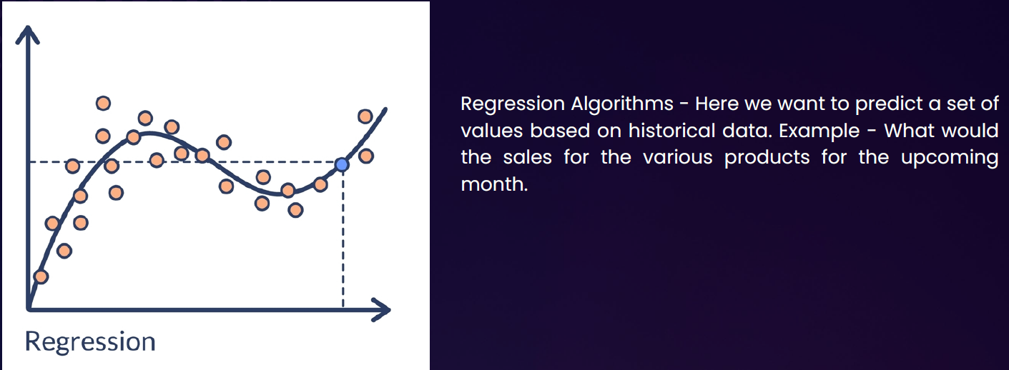

#### ANOMALY DETECTION ALGORITHM

* This is used to detect if data deviates from the norm
* Example: used to detect fraudulent credit card purchase

#### CLUSTERING ALGORITHM

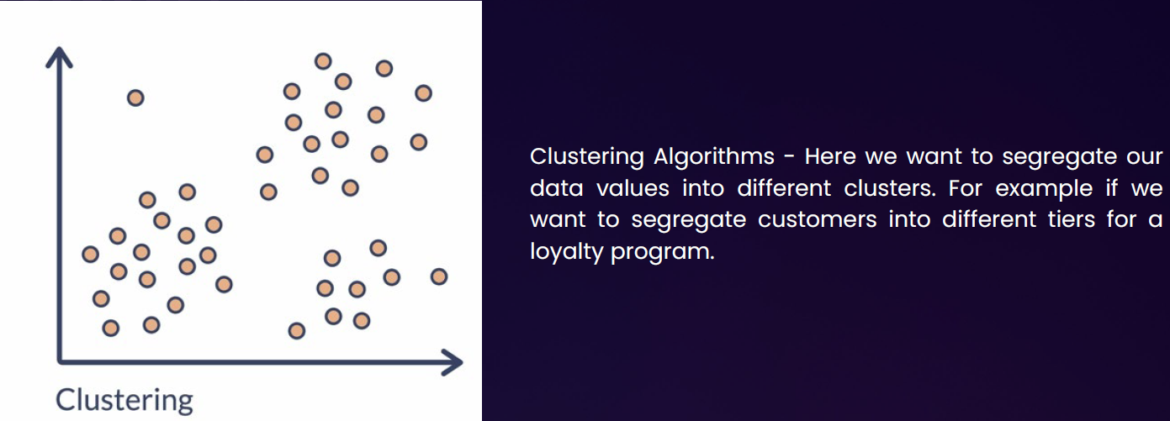

# AZURE MACHINE LEARNING WORKSPACE

* To work on ML in Azure we need to deploy Azure ML workspace.

## CREATING AZURE MACHINE LEARNING WORKSPACE

* The Azure ML workspace encapsulates the ML artifacts that includes datasets, ML models etc.
* When we deploy ML workspace, there are other resources also get deployed along with it

|  |  |  |  |  |  |  |  |  |  |
| --- | --- | --- | --- | --- | --- | --- | --- | --- | --- |
|  | |  |  | | --- | --- | | **STORAGE ACCOUNT** | * When we run the Job to train the machine learning model, these storage accounts are used to store the logs | | **CONTAINER REGISTRY** | * Used to store the images of created docker container | | **KEY VAULT** | * To score secrets needed by workspace or other resources | | **APPLICATION INSIGHT** | * To collect diagnostic information from the inference endpoints | |

* Provide the name of ML workspace 🡪 Review & Create (*We will keep default selection of other options in the wizard*)

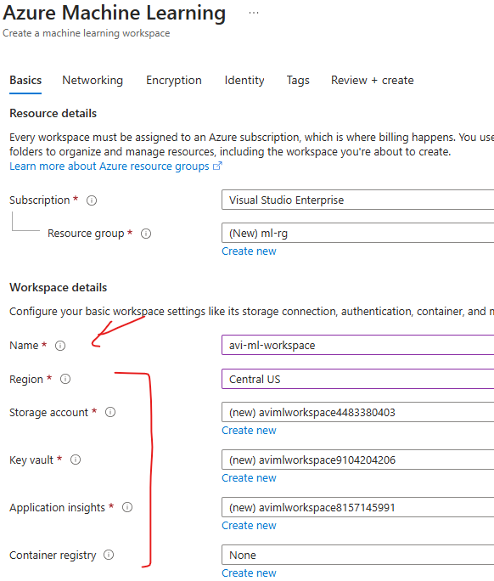

CREATED RESOURCES

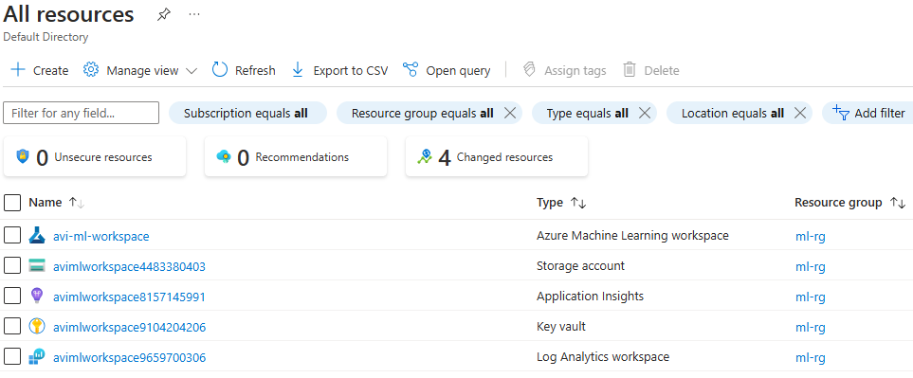

* The ML workspace is a separate interface , hence to launch the workspace 🡪 Click on Launch Studio

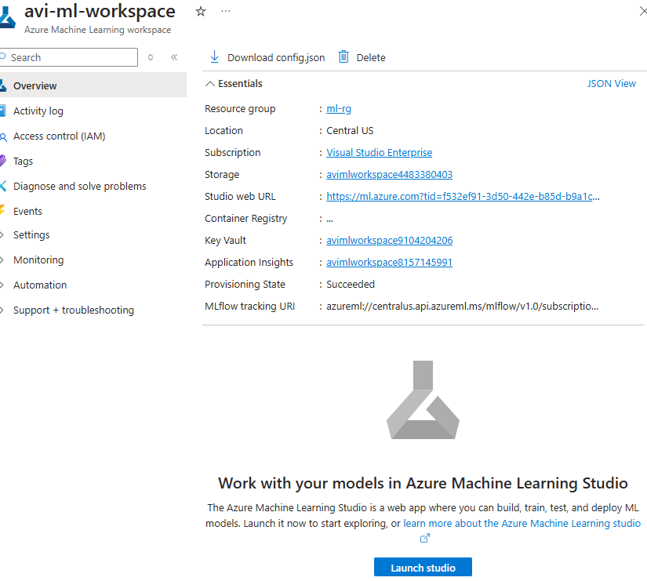

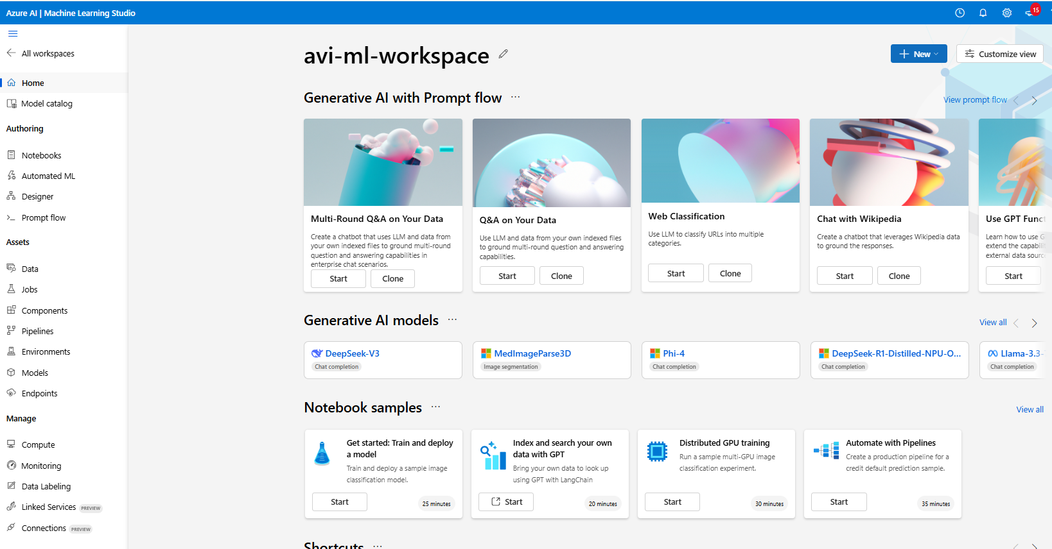

## WORKING WITH ML WORKSPACE

1. **AZURE ML DESIGNER**
   1. Once the workspace is set up, we can access Azure ML Designer, a visual interface within Azure ML that allows us to build machine learning pipelines using pre-built components.
   2. This eliminates the need for extensive coding or development.
2. **CREATING A NEW PIPELINE**
   1. In Azure ML Designer, you create a new pipeline to start building your machine learning model. A pipeline in Azure ML is a series of connected components that define the workflow and operations performed on the data.
3. **USING PRE-BUILT COMPONENTS**
   1. Azure ML Designer provides a set of pre-built components that can be used in the pipeline.
   2. These components represent specific tasks or operations, such as data ingestion, data preprocessing, feature extraction, model training, and evaluation.
   3. We can choose from a variety of components based on your specific requirements.
4. **DRAGGING COMPONENTS ONTO THE CANVAS**
   1. In the Azure ML Designer canvas, we can drag and drop the pre-built components onto the canvas to build the model pipeline.
   2. Components can be connected to define the flow of data and the sequence of operations.
5. **CONFIGURING AND CONNECTING COMPONENTS**:
   1. After placing the components on the canvas, we can configure their properties and connect them to define the data flow and processing steps.
   2. This includes specifying input and output connections, setting parameters, and adjusting component settings.

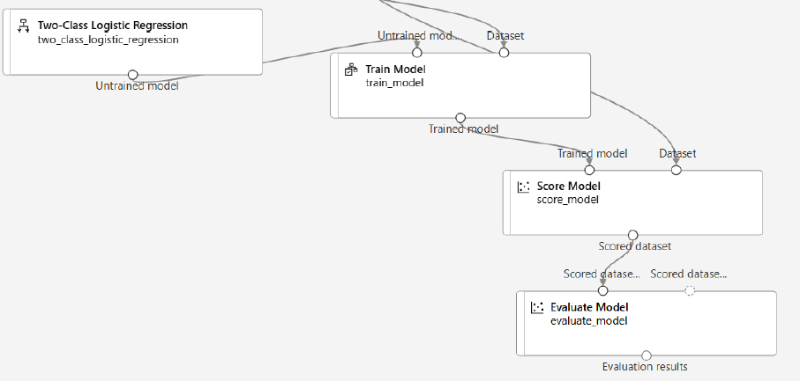

1. **TRAINING AND BUILDING THE MODEL**:
   1. Once the pipeline is set up, we can start the training and building process. This involves providing the necessary data to the pipeline and executing the components in the desired sequence.
   2. Data flows through the pipeline, and each component performs its assigned task, such as data transformation, model training, or model evaluation.
2. **MONITORING AND ITERATING**:
   1. Azure ML provides monitoring capabilities to track the progress and performance of the pipeline.
   2. We can monitor metrics, logs, and outputs to assess the model's performance and iterate on the pipeline configuration if necessary.

## BUILDING CLASSIFICATION ML PIPELINE

* The classification model is used to predict the values that fall in into simple category.
* In the below example we will use a pre-built dataset to train the model (Azure ML workspace has multiple pre-built data set). We will be using “***adult_census_income_binary_classification***”. In real world scenario we need to get the data set from one or multiple sources and then clean the data, which can then be used to train the ML model.
* Based in the below dataset model give the prediction of income (label)(*Income has two categories >50k or <=50k*)

|  |
| --- |
| Our aim is to build a machine learning model. This model will be used to classify the income of individuals into 2 classes - <=50K or > 50K |

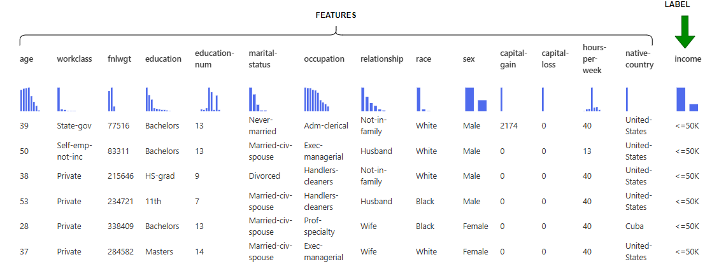

### STEP 1: SPLIT DATA

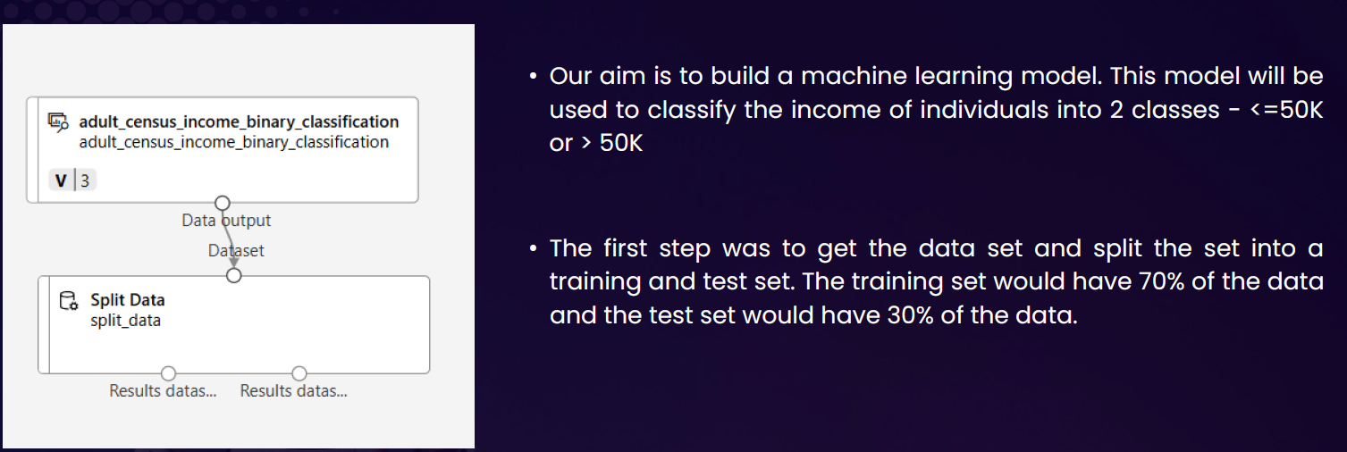

#### DATA SET

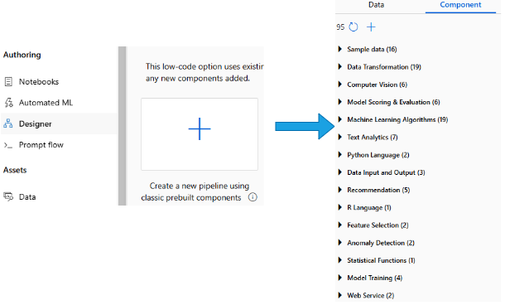

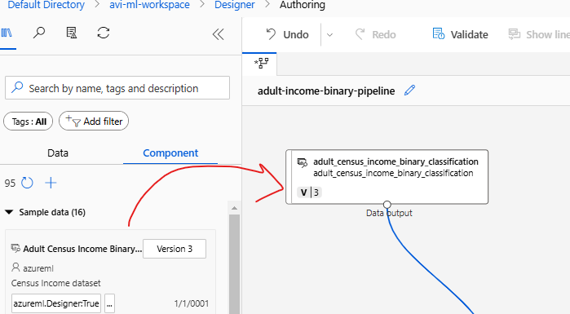

#### SPLIT DATA

|  |  |
| --- | --- |
|  | * The dataset is then further split in certain ratio e.g. 70% of data can be used to train the model and 30% for validation * For the drag & drop the “Split data” component and configure the desired ratio of data split |

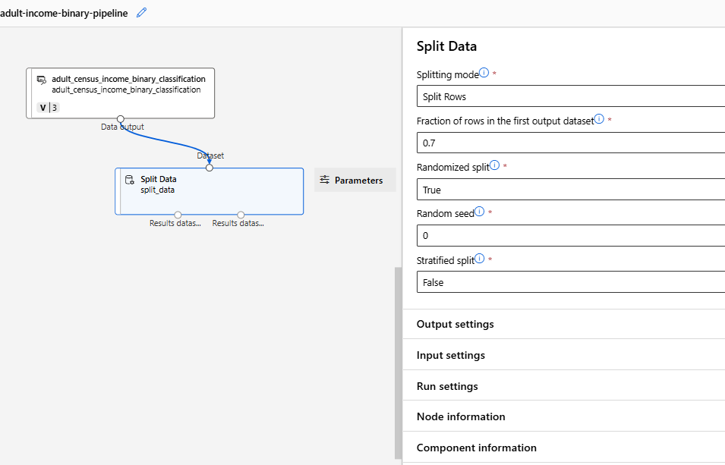

#### SETTING UP THE COMPUTE INSTANCE

|  |  |
| --- | --- |
|  | * To build/ train the ML model, we need to run the pipeline. * To execute the pipeline, we need a compute instance where the pipeline will execute. The compute instance is a Azure VM under the hood * Note: The ML algorithm is set of instructions / code. This instruction must iterate through large datasets to look at the pattern in the data. Hence, it needs a compute machine to run the instruction and build the ML model |

* The compute instance VM are available in different SKUs. For the below example- we will select ***Standard_DS3_v2*** VM
* For this example - we will keep other options as default and create the VM

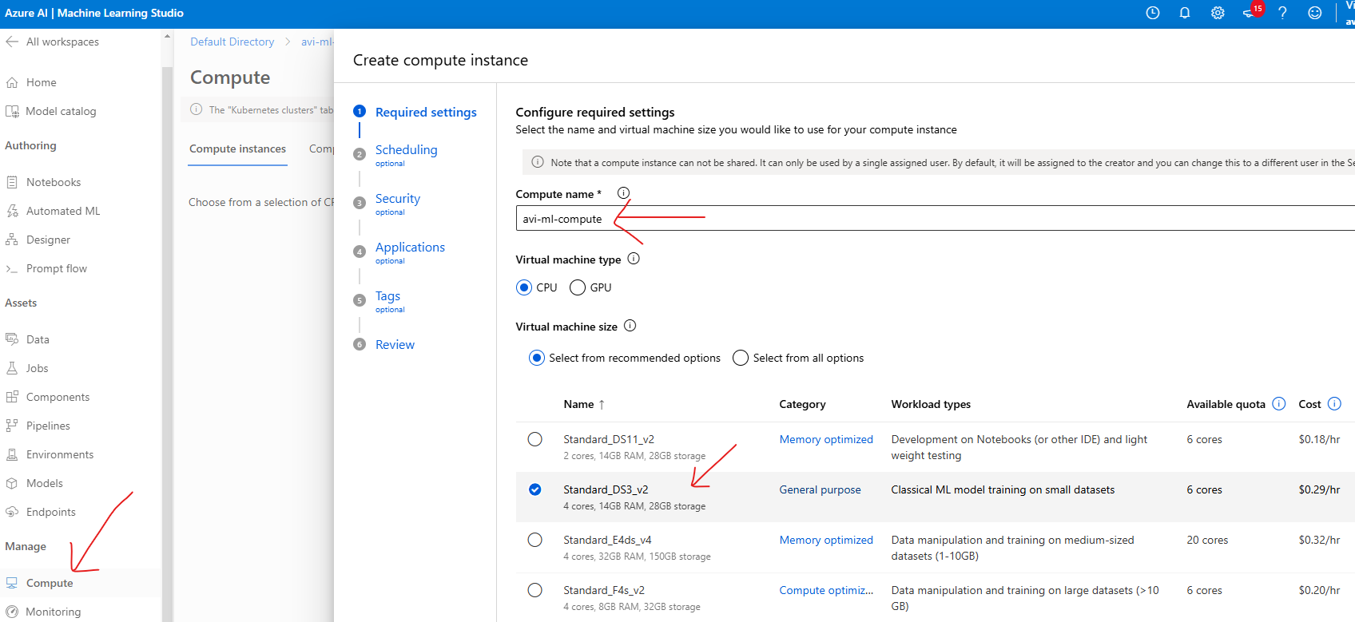

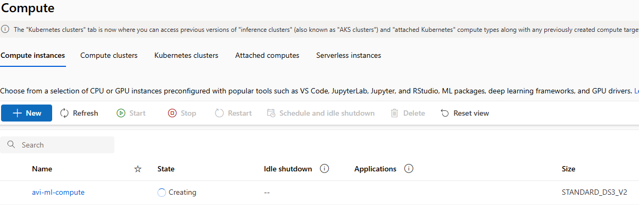

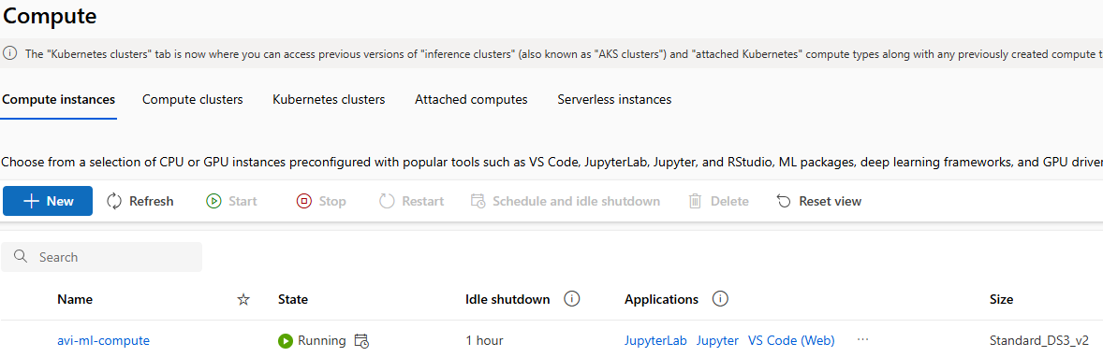

#### RUNNING THE PIPELINE

* After the compute instance is setup, we can now run the pipeline (Note – the pipeline is not yet complete)
* To run the pipeline, we need to create an experiment
* The execution aka experiment will create a Job. This Job will execute on the compute machine
* Go to Designer 🡪 Configure & Submit

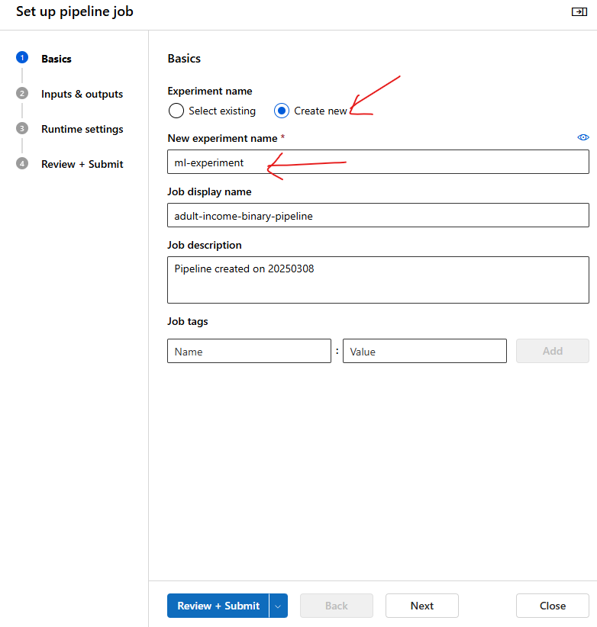

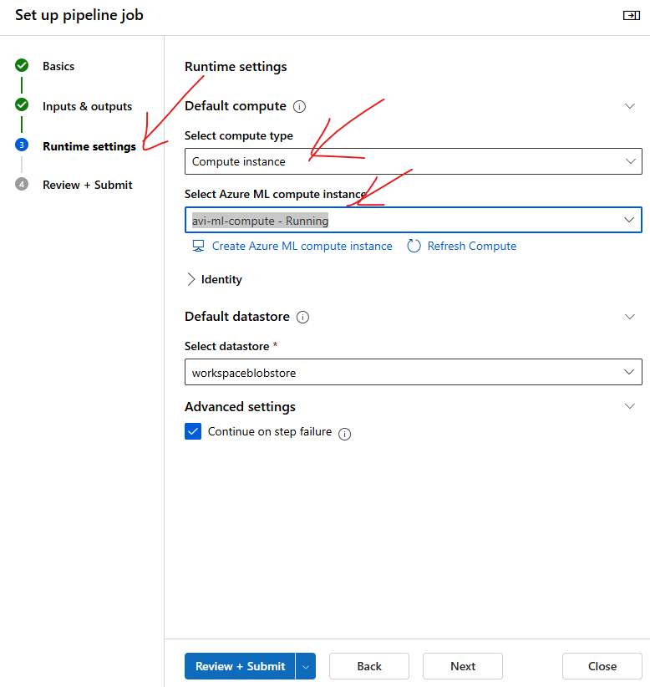

* The Job will download the entire dataset in the compute machine and then split the data

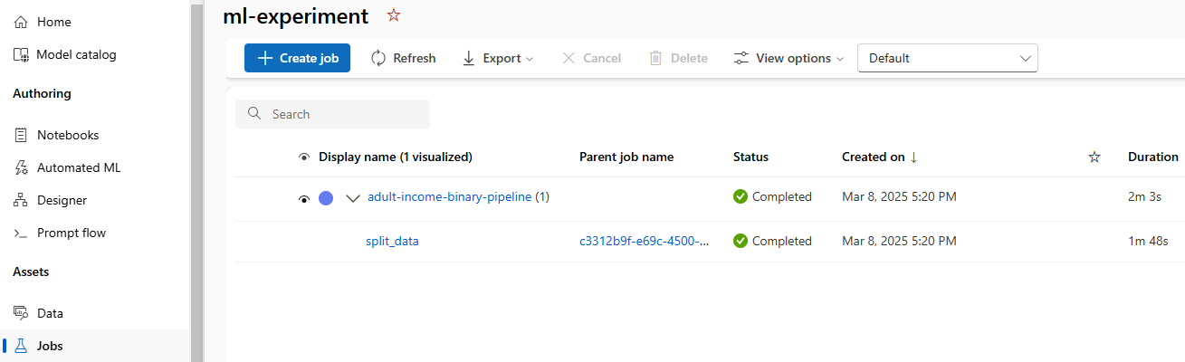

* The split data component will split the data in to 2 datasets in 70-30 ratio.

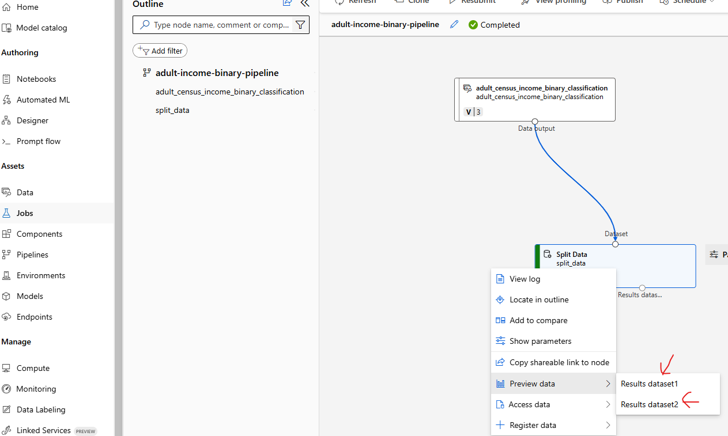

### STEP 2: TRAIN MODEL

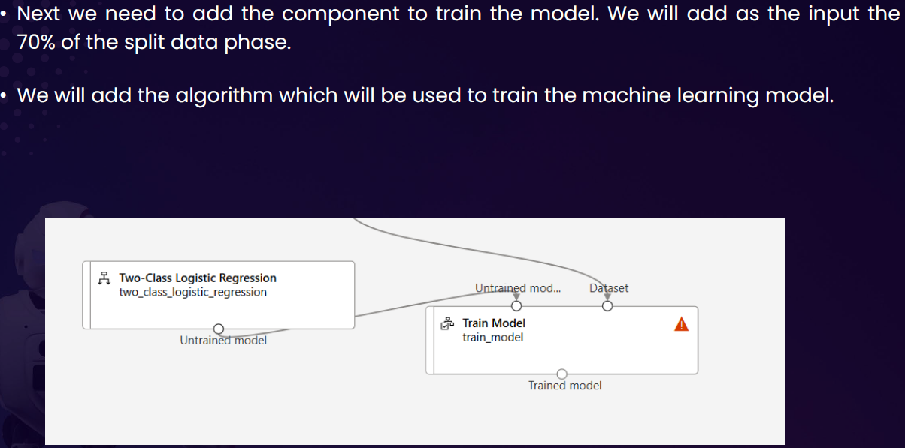

#### CONFIGURE THE LABEL

To configure the model

* Click on Pipeline Interface 🡪 Train Model Component 🡪 Edit Column

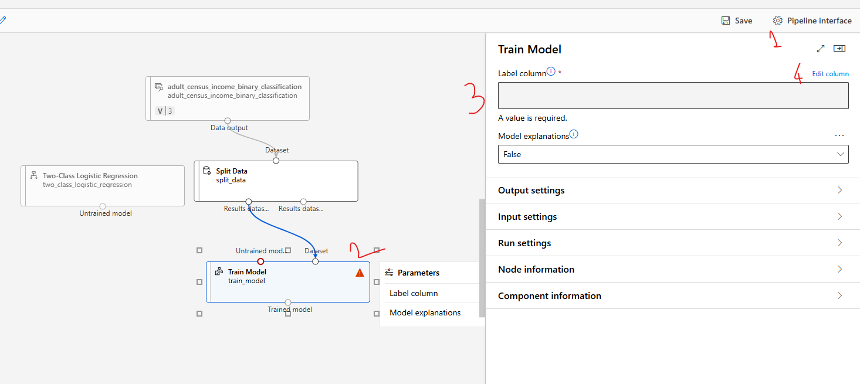

* Provide the name of the column name of the “**Label**” 🡪 Save

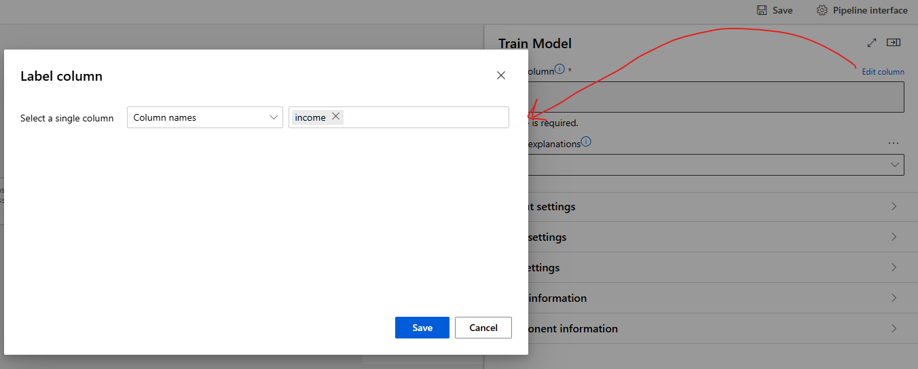

#### CONFIGURE THE ALGORITHM

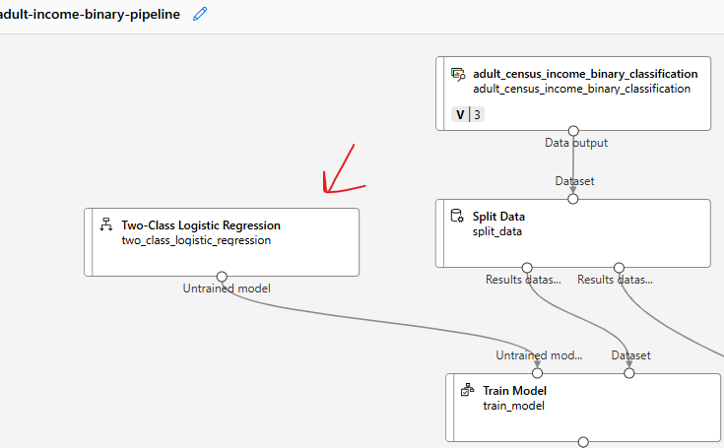

### STEP 3: SCORE MODEL

* Score model is to test the model performance. For that we need to feed the 30% of the test data and Model as an input

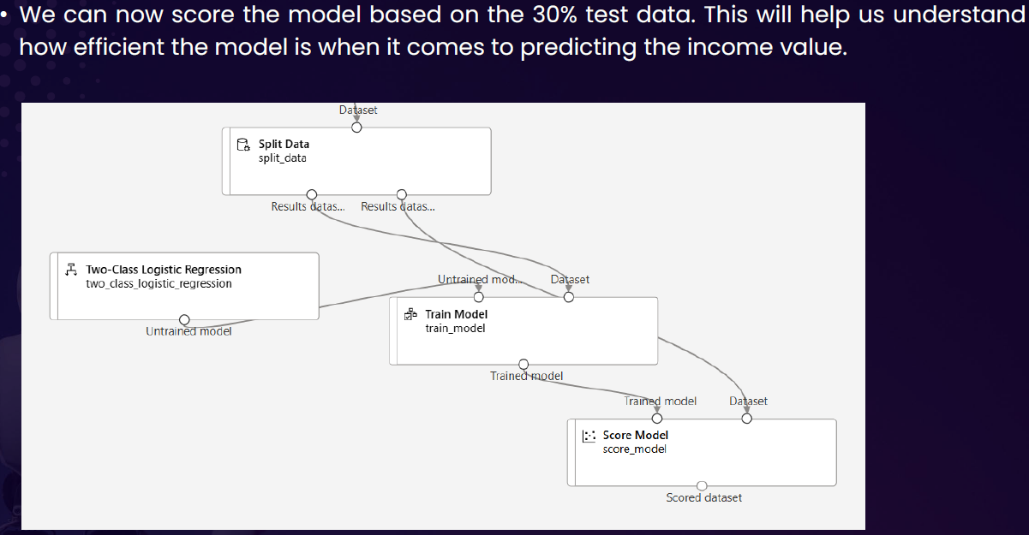

### STEP 4: EVALUATE MODEL

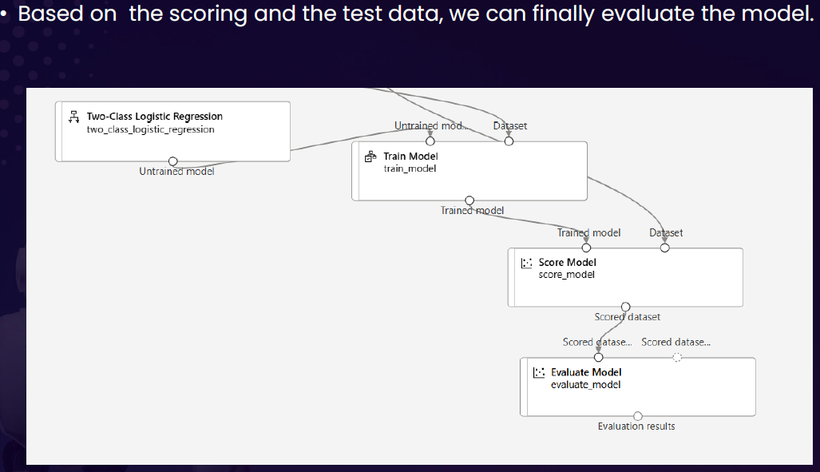

### STEP 5: RUN THE PIPELINE – EXPERIMENT

* Designer 🡪 Configure & Submit 🡪 Then Configure the Experiment 🡪 Review + Submit
* This will create & submit a new Job that will run the entire pipeline
* To view the status of Job . Go to Job and open the experiment

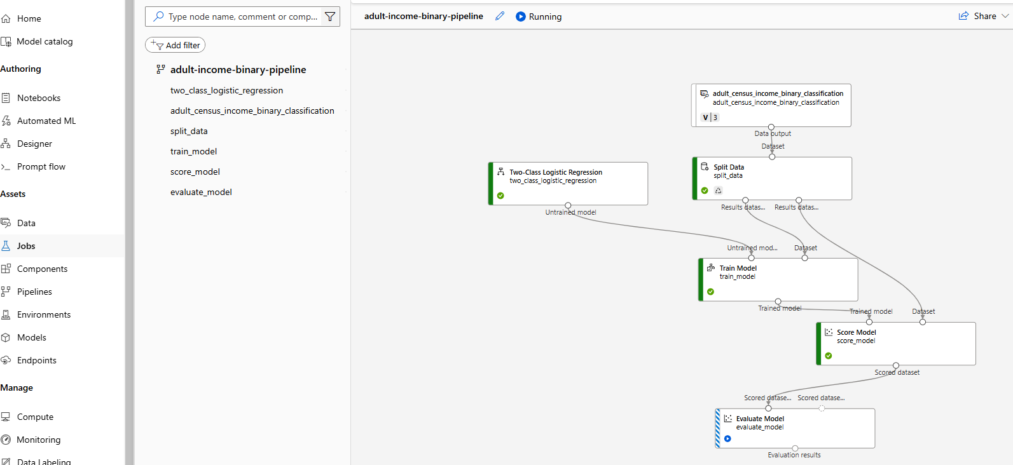

### EVALUATION OF MODEL RESULT

* **Every model has their specific evaluation metrices. Below are the details of metrices of classification model.**

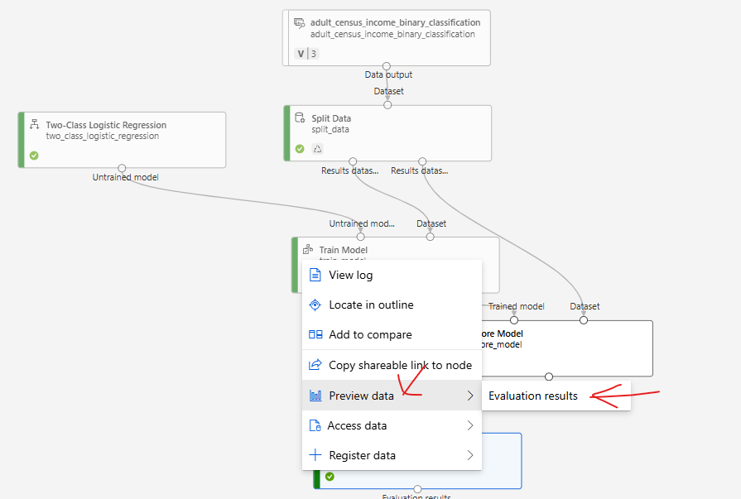

* **There are different metrics that can be used to evaluate model performance, such as Accuracy and Precision. The closer these metrics are to 1, the more accurate the model is.**
* **One of the important metrics is “Confusion Metrics”**

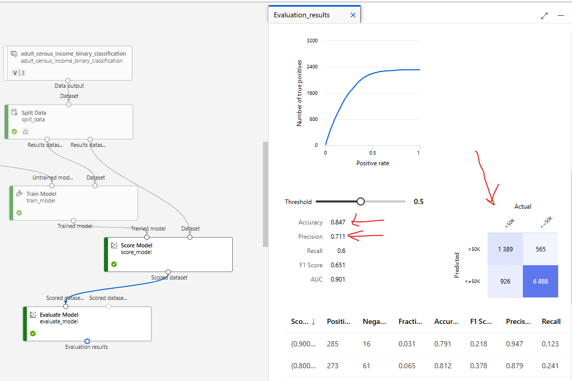

#### CONFUSION MATRICES

* Confusion matrices are the way to evaluate the performance of **a classification model**.
* It is a table that shows the number of correct and incorrect predictions made by the model.
* The table is divided into four quadrants:
  1. *true positives (correctly predicted positive instances),*
  2. *true negatives (correctly predicted negative instances),*
  3. *false positives (incorrectly predicted positive instances)*
  4. *false negatives (incorrectly predicted negative instances).*

By analyzing the values in the confusion matrix, various performance metrics such as accuracy, precision, recall, and F1 score can be calculated to assess the model's effectiveness.

|  |  |
| --- | --- |
|  |  |

## DEPLOYING THE ML MODEL

Once the evaluation is done, we can go ahead and do the deployment so that request can be submitted with an input.

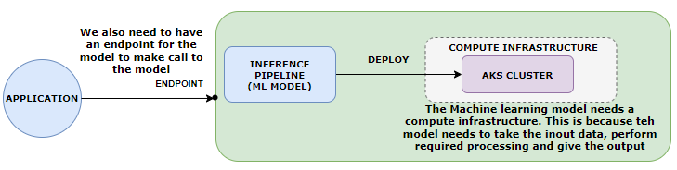

***The ML model will be deployed to AKS cluster(Compute)***

|  |  |
| --- | --- |
| Example | INPUT DATA TO MODEL AS POST REQUEST |
| * The expectation is to predict the income when the following input is provided to the model | **{"Inputs": {"WebServiceInput0": [**  **{ "age": 39,**  **"workclass": "State-gov",**  **"fnlwgt": 77516,**  **"education": "Bachelors",**  **"education-num": 13,**  **"marital-status": "Never-married",**  **"occupation": "Adm-clerical",**  **"relationship": "Not-in-family",**  **"race": "White",**  **"sex": "Male",**  **"capital-gain": 0,**  **"capital-loss": 0,**  **"hours-per-week": 60,**  **"native-country": "United-States",**  **"income": ""**  **}**  **]**  **}}** |

* After the successful run job- we need to create inference pipeline

### INFERENCE PIPELINE

* **An inference pipeline is a way to deploy and manage an end-to-end workflow for deploying machine learning models as web services**.
* It allows us to create a pipeline that consists of multiple steps, including data preprocessing, model scoring, and post-processing.
* The inference pipeline in Azure ML workspace provides a streamlined and automated process for deploying models and making predictions on new data. It helps in simplifying the deployment process, managing dependencies, and scaling the inference workload.
* With an inference pipeline, you can encapsulate the entire workflow and deploy it as a single endpoint. This makes it easy to integrate the model into applications or systems for real-time predictions.
* **The inference pipeline can be created and managed using Azure ML SDK, Azure Portal, or other Azure ML tools.**

#### CREATING AN INFERENCE PIPELINE

* Go to jobs 🡪 Open the Job

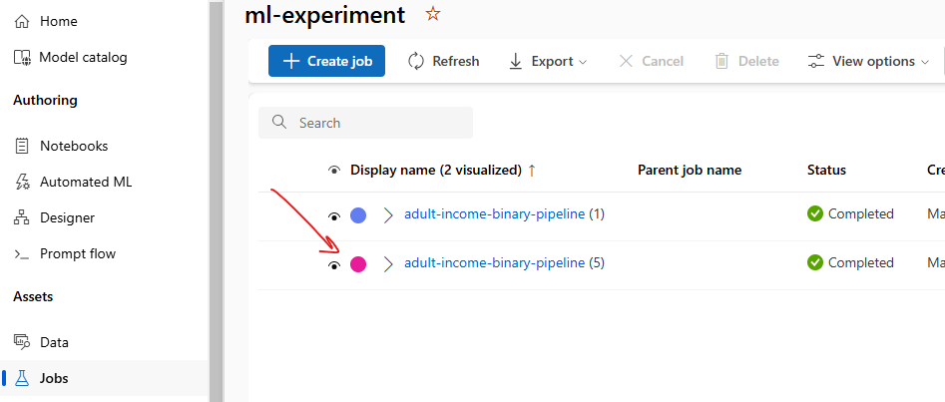

* Create a “Real time Inference Pipeline” .

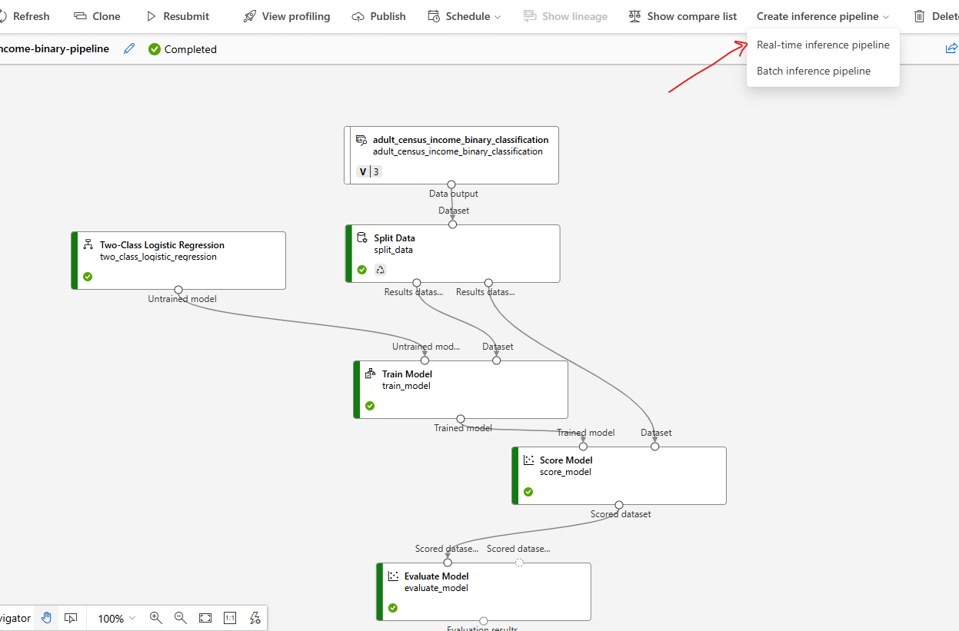

* This will create a new pipeline, with additional component “Web Service Input” and “Web Service Output”
* Note: We can remove the Evaluate Model component (as we have already evaluated the model)

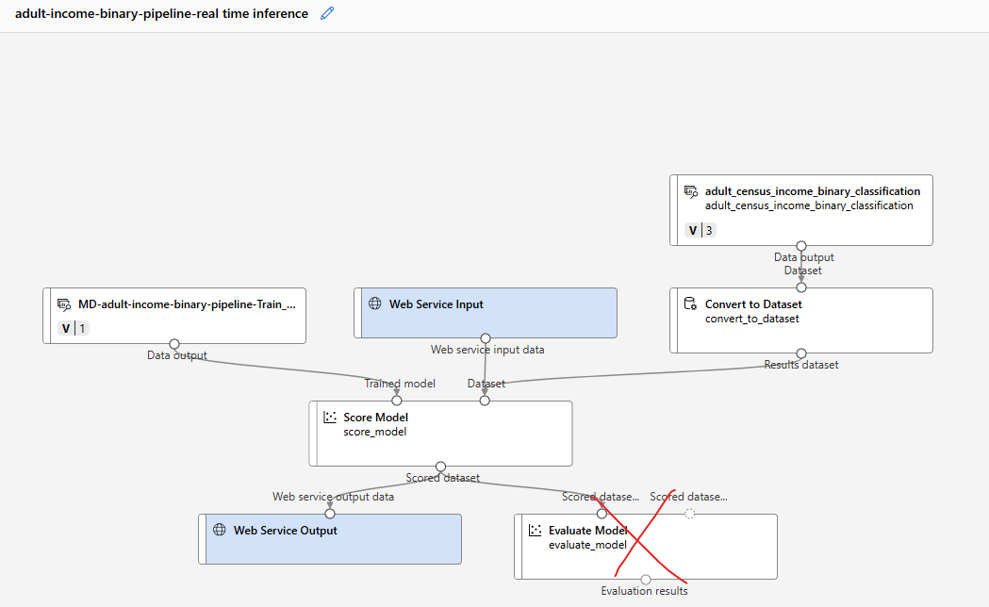

#### RUN THE INFERENCE PIPELINE

* Save and click on “Configure and Submit” to configure the Job

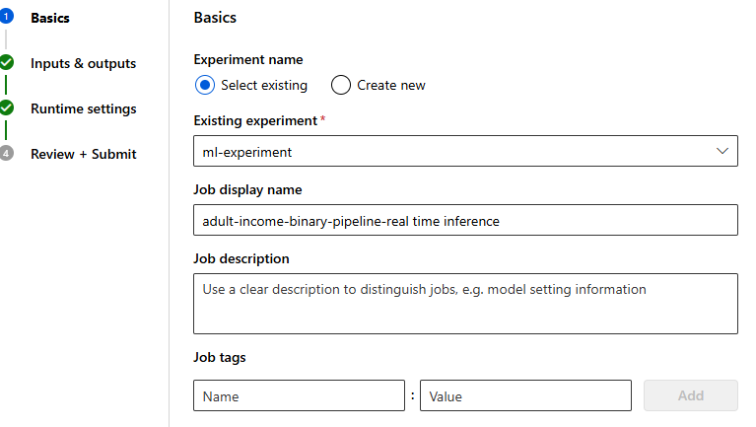

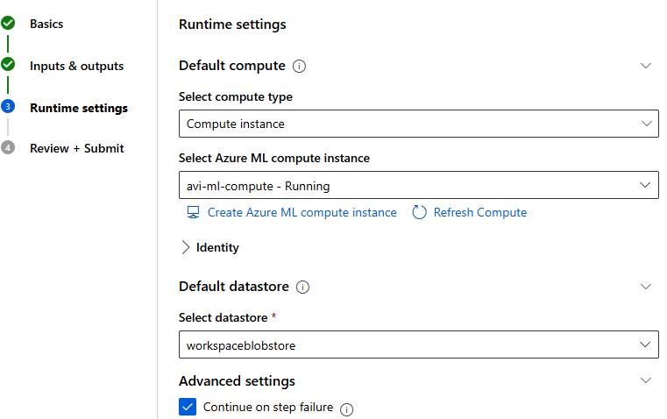

#### COMPUTE

* We will now create a compute to deploy the ML model

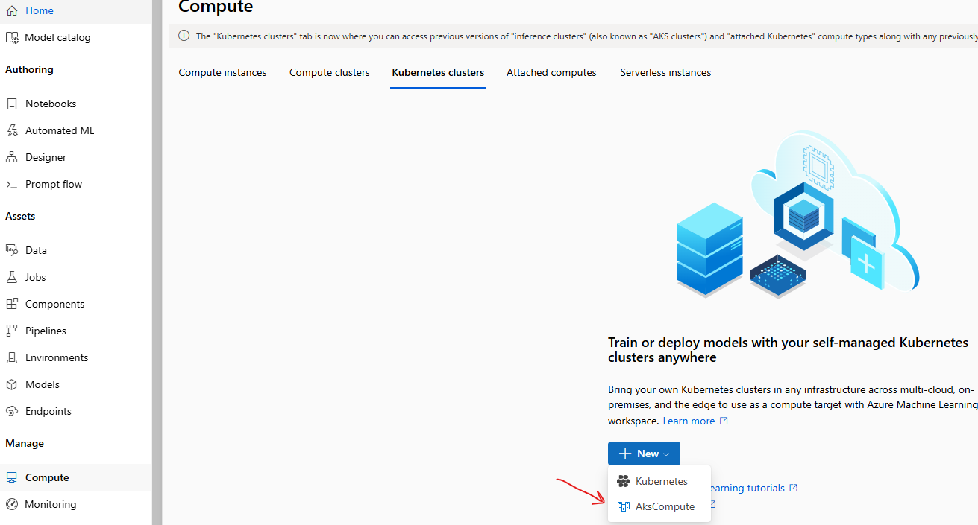

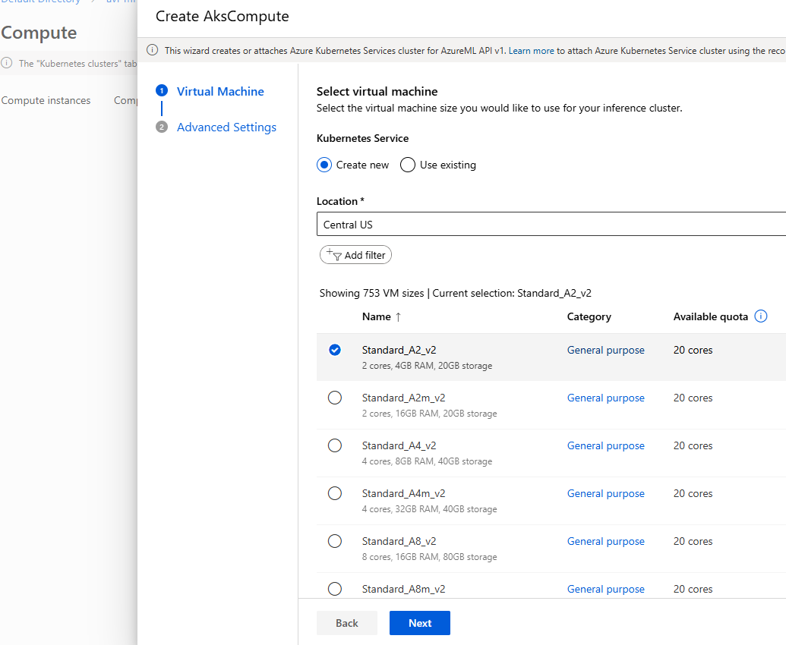

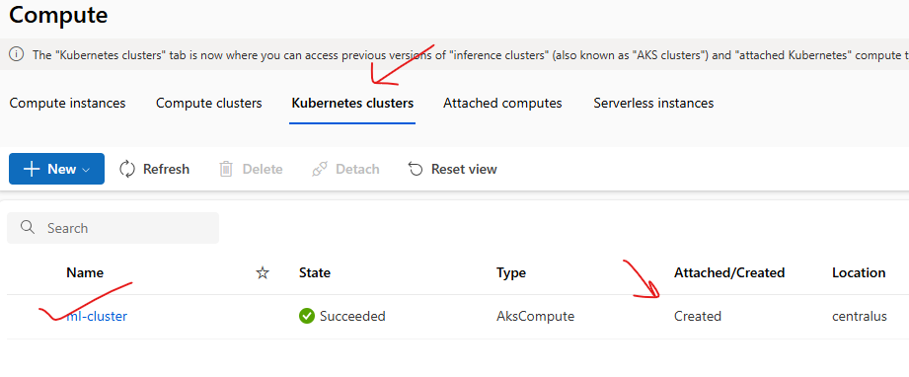

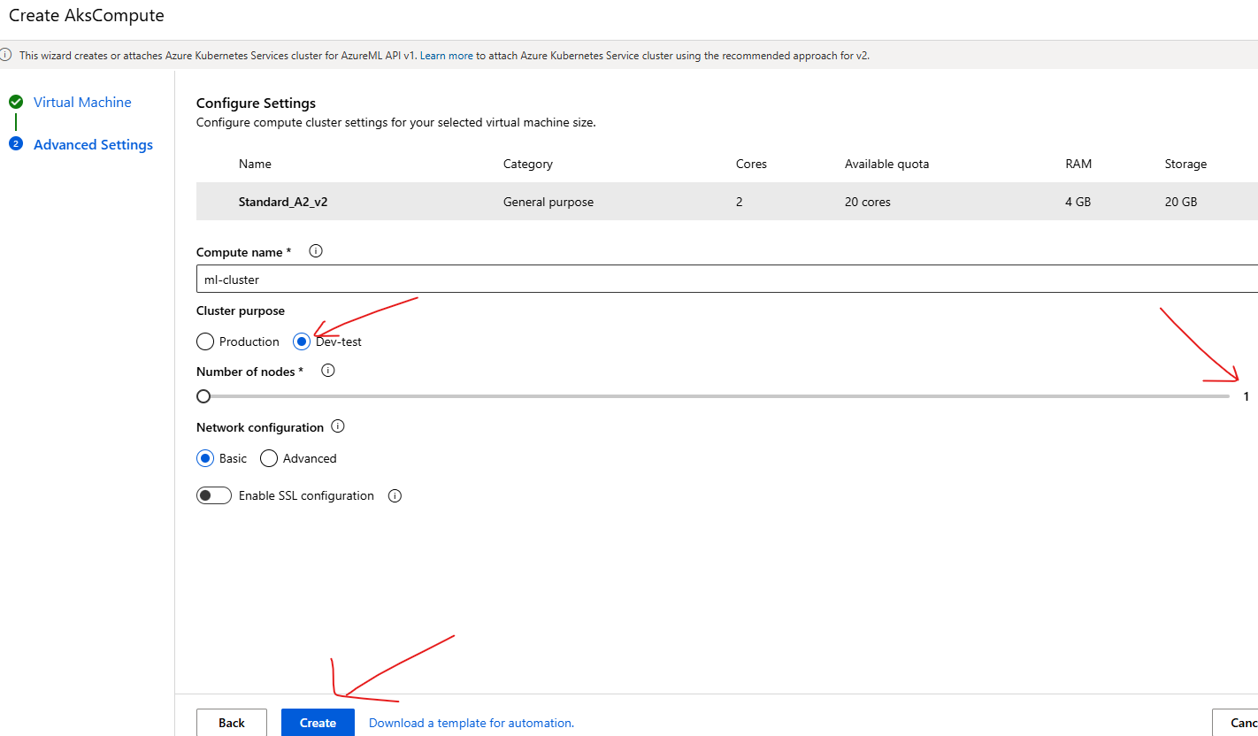

* Go to job 🡪 open the Inference pipeline Job 🡪 Deploy
* This will deploy the model to the compute instance (Kubernetes Cluster)

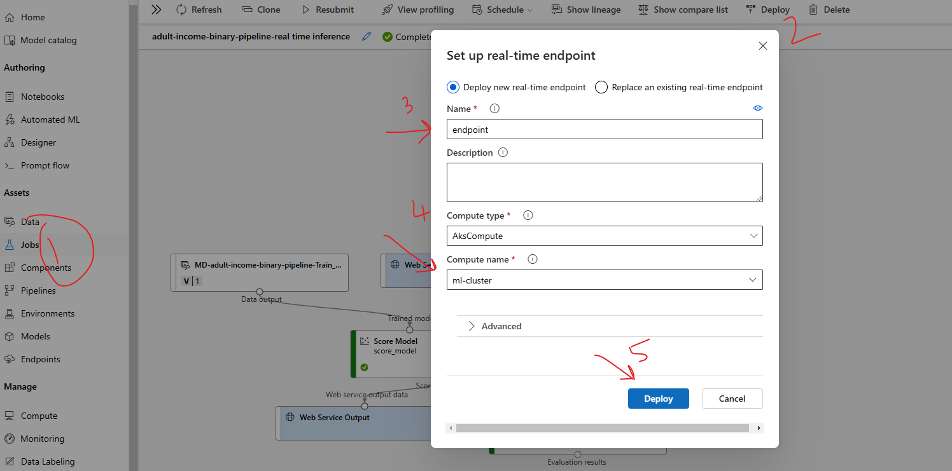

* After the deploy it will create an endpoint using which the ML model can be called. Note – The deployment status can be check using *Endpoint 🡪 Deployment State.*
* After the deployment the deployment state will be updated as “**Healthy**”

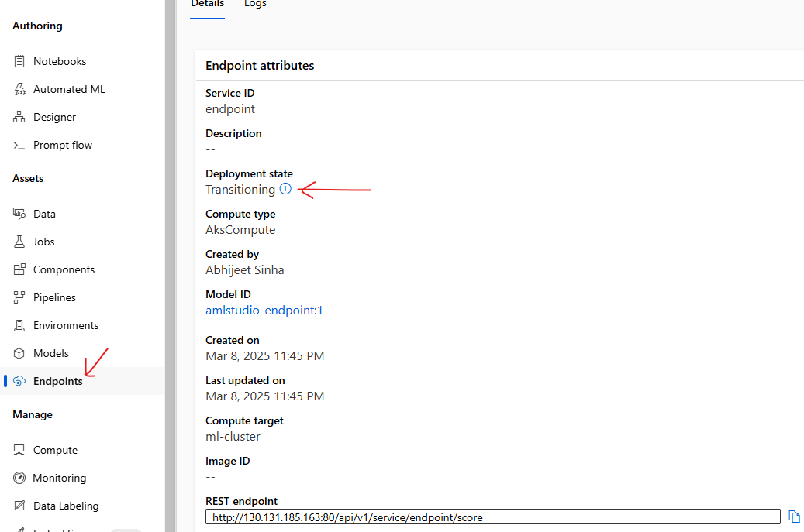

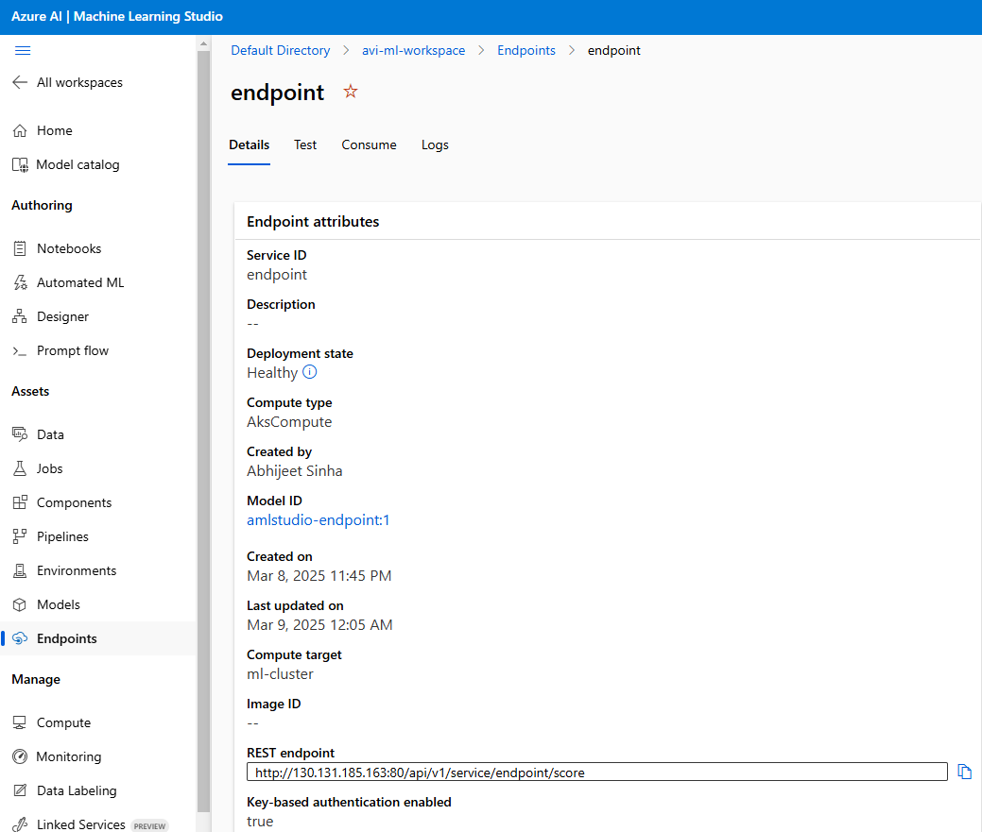

## TESTING THE MODEL

|  |  |
| --- | --- |
| INPUT DATA TO MODEL AS POST REQUEST |  |
| **{"Inputs": {"WebServiceInput0": [**  **{ "age": 39,**  **"workclass": "State-gov",**  **"fnlwgt": 77516,**  **"education": "Bachelors",**  **"education-num": 13,**  **"marital-status": "Never-married",**  **"occupation": "Adm-clerical",**  **"relationship": "Not-in-family",**  **"race": "White",**  **"sex": "Male",**  **"capital-gain": 0,**  **"capital-loss": 0,**  **"hours-per-week": 60,**  **"native-country": "United-States",**  **"income": ""**  **}**  **]**  **}}** |  |

### CONSUMING MODEL USING ENDPOINT

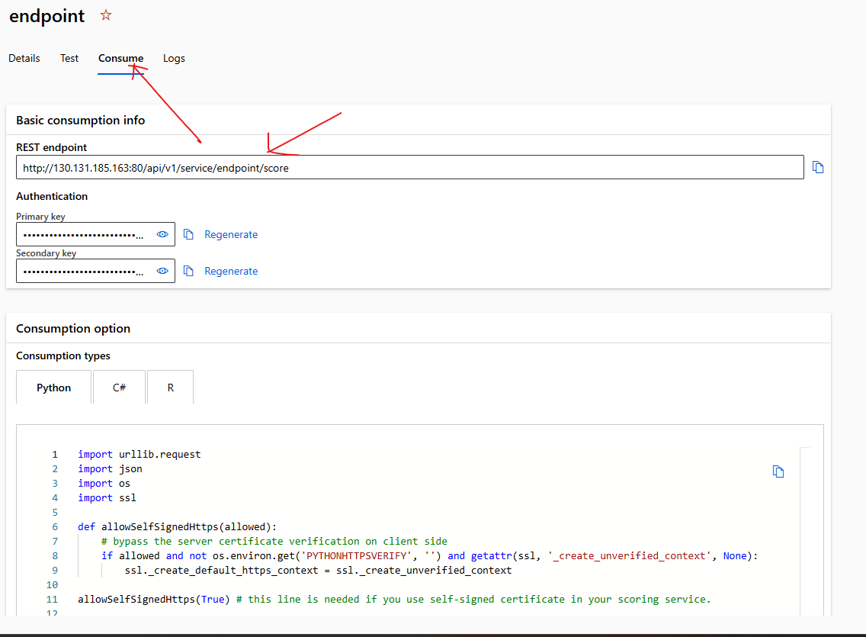

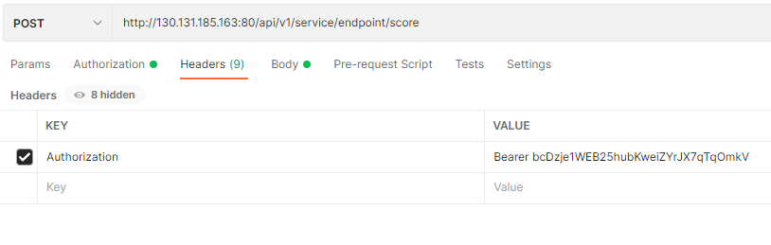

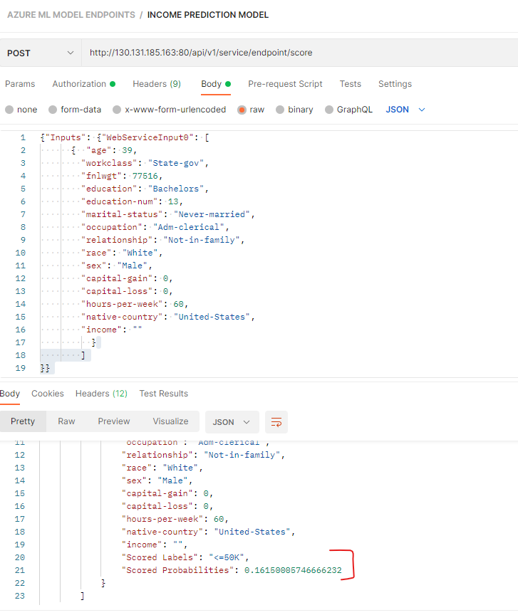

# AZURE AI VISION SERVICE

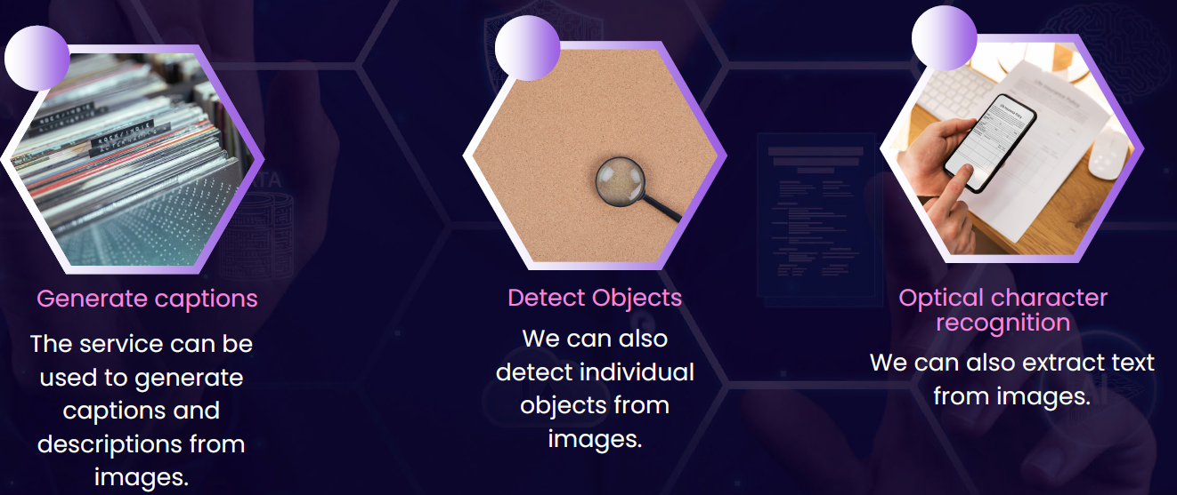

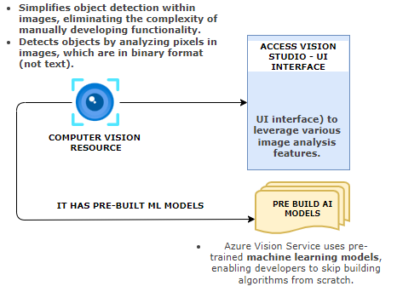

## CREATING AI VISION SERVICE

|  |  |
| --- | --- |
|  |  |

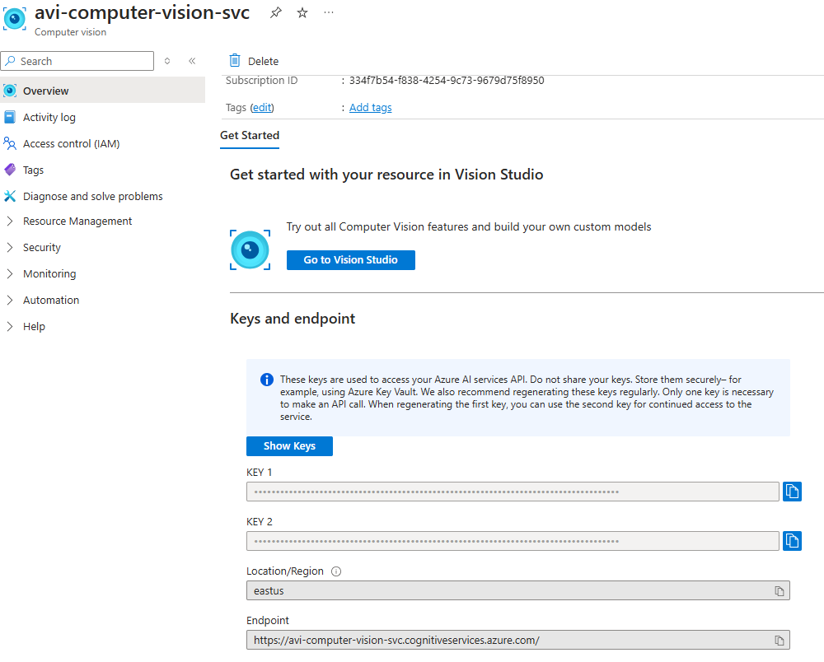

## VISION STUDIO

* To use different feature of Azure computer vision service , navigate to Visual Studio : <https://portal.vision.cognitive.azure.com/>

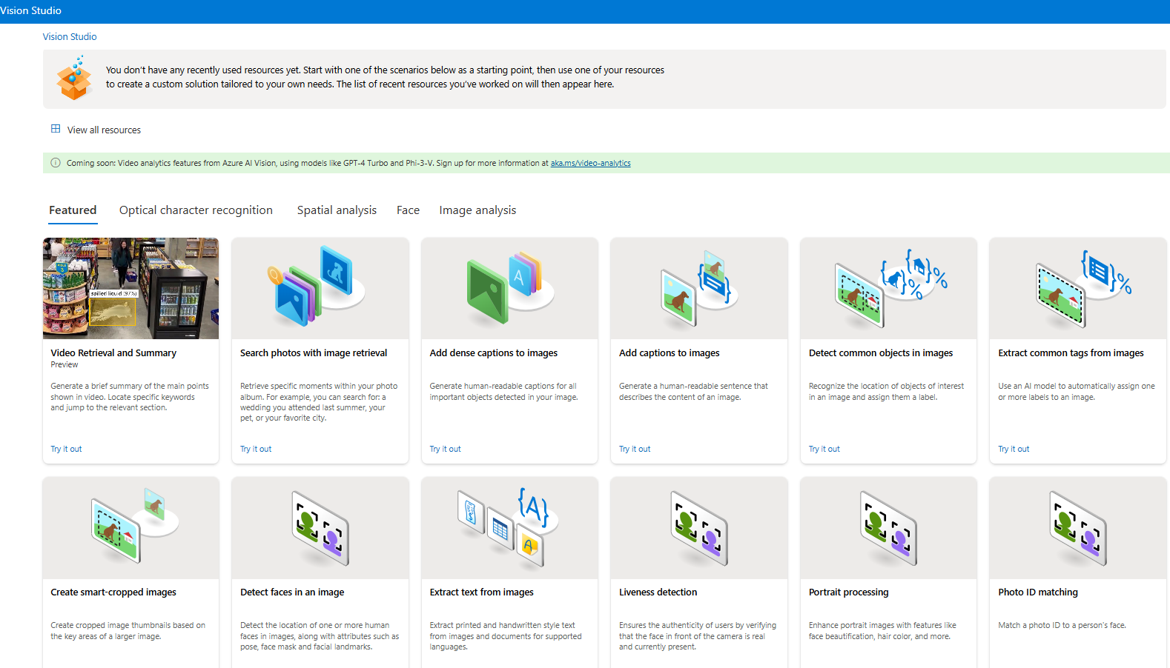

### FEATURE - EXTRACT COMMON TAGS FROM IMAGES

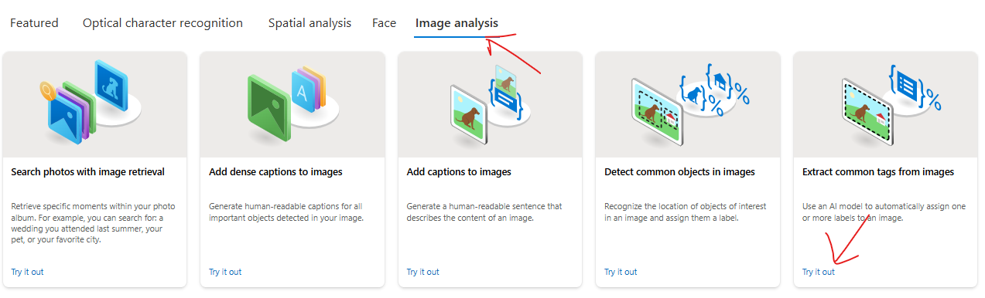

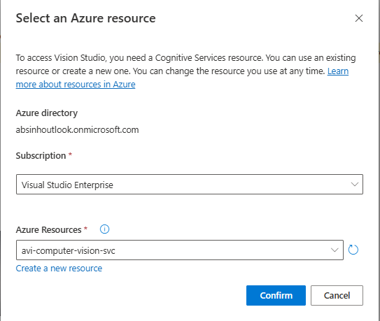

* For demo purpose select the prebuilt images. The feature will analyze the image and assign different tags to it
* Example - In below example - It understood that we do have a person within the image ,The person is having footwear in place. There is a wall behind the person.
* It's also giving a confidence score,so it has 99% confidence that this is part of a sport.It has 99% confidence that this is a person, so on and so forth. **The confidence score tells the probability of the object being correctly detected.**

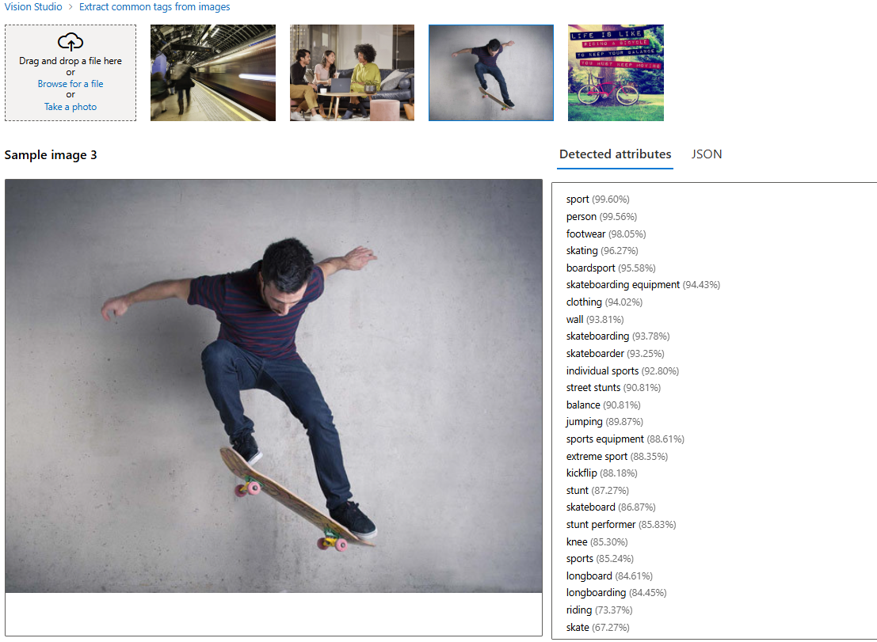

### FEATURE – ADD CAPTION TO IMAGES

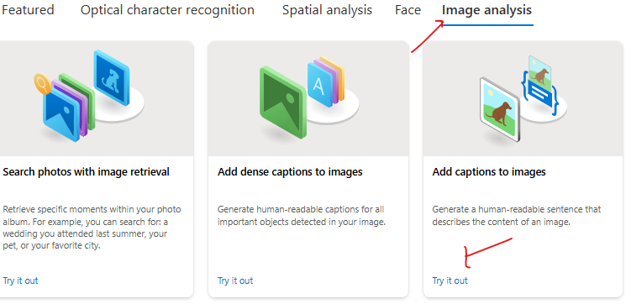

* **This feature creates a caption for the image**

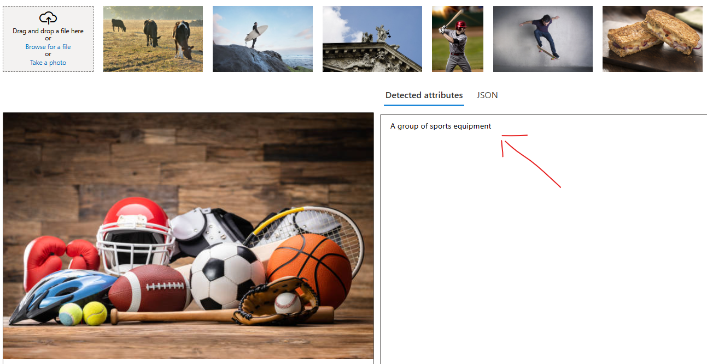

### FEATURE – OBJECT DETECTION

|  |  |
| --- | --- |
|  | * This feature identify and label common objects within an image. This is part of Azure's Object Detection functionality, integrated into the Computer Vision API, which uses pre-trained machine learning models to analyze visual content. |

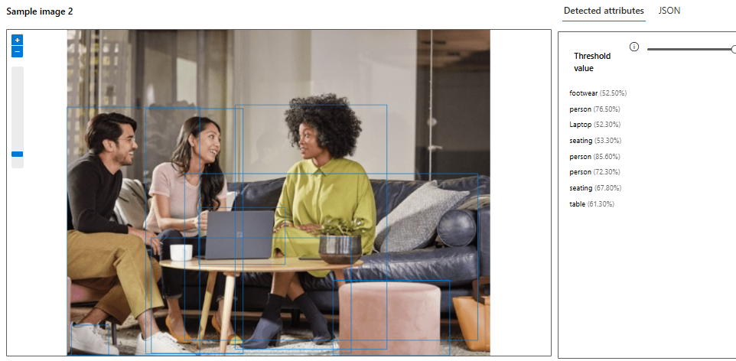

**HOW DOES OBJECT DETECTION WORK?**

* Azure Vision Studio processes the image and identifies objects by drawing bounding boxes around them.
* Each bounding box is associated with a label (object name) and a confidence score (the probability of the object being correctly detected). **Each object comes with a confidence score—e.g., 0.98—indicating the likelihood that the object is correctly identified. Higher scores mean higher accuracy**
* Detected objects can include everyday items such as cars, chairs, animals, plants, and fruits, depending on the image content.

**EXPOSING THE DATA**

* The output from these service can be exposed as an API as JSON

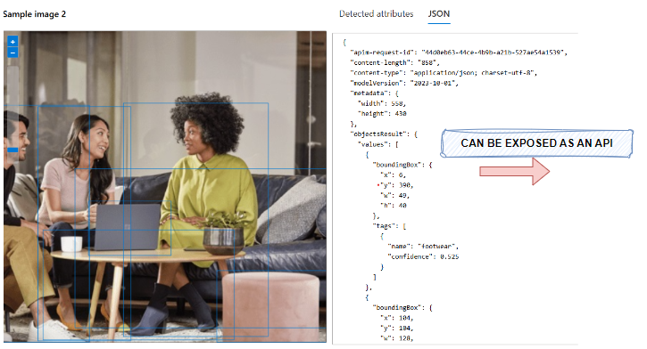

### FEATURE – OPTICAL CHARACTER RECOGNITION

|  |  |
| --- | --- |
|  | * The Optical Character Recognition (OCR) feature in Azure Vision Studio is a powerful AI-enabled tool for **extracting text from images**. * It can detect both printed and handwritten text, making it ideal for tasks like text transcription, document digitization, automated data extraction, and more.     OCR SERVICE PROVIDES:   * Text Detection: Recognizes text areas in the image. * Text Extraction: Returns the detected text along with its spatial coordinates in the image. * Language Identification: Automatically identifies the language of the extracted text. |

HOW OCR WORKS?

OCR uses machine learning models trained to analyze the pixel patterns in an image and map them to alphanumeric text. This can detect text in various formats, such as:

* Digital Document Scans (e.g., PDFs, receipts, invoices, or forms).
* Embedded Text in Images (e.g., road signs, labels, packaging).
* Handwritten Text (e.g., notes, letters, or signatures).

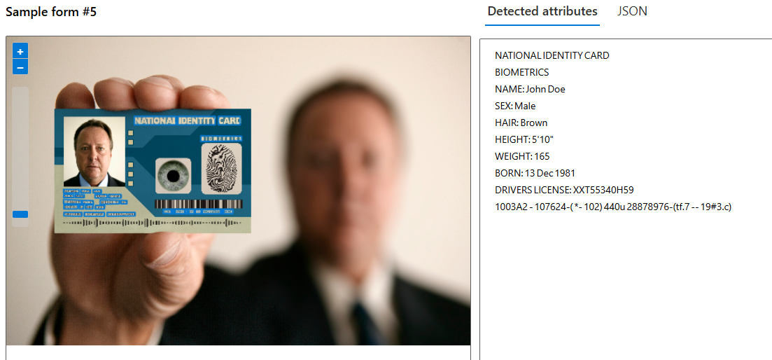

### API CALL TO VISION SERVICE – POSTMAN

* Documentation : <https://learn.microsoft.com/en-us/rest/api/computervision/image-analysis/analyze-image?view=rest-computervision-v4.0-preview%20(2023-04-01)&tabs=HTTP>

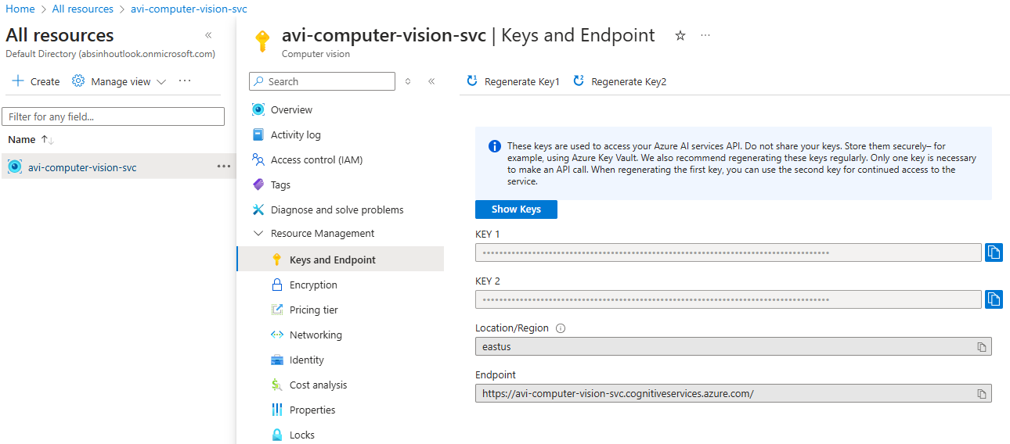

#### POSTMAN REQUEST

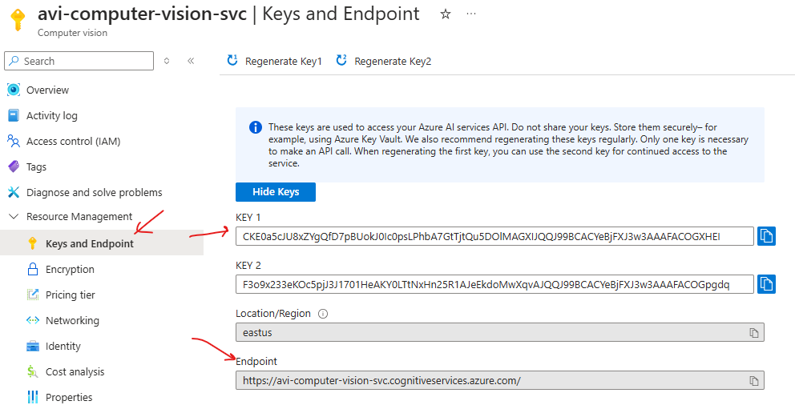

* REQUEST URL : <https://avi-computer-vision-svc.cognitiveservices.azure.com/computervision/imageanalysis:analyze?api-version=2023-04-01-preview&features=tags>
* HEADERS

|  |  |
| --- | --- |
| **Ocp-Apim-Subscription-Key** | Mention either of the key |
| **Content-Type** | application/octet-stream |

* IMAGE USED IN REQUEST



URL PARAMETERS

* We can specify the value of **features** QS based on the visual feature we are looking for

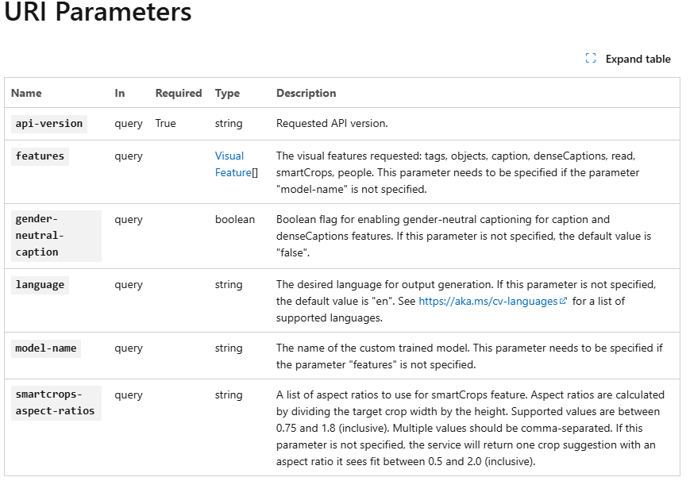

EXAMPLE

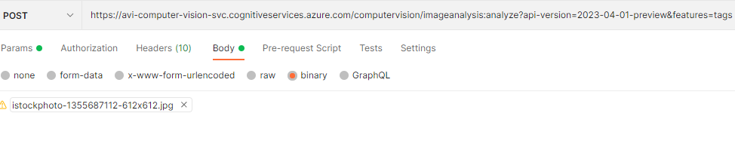

SAMPLE POSTMAN REQUEST FOR IMAGE TAGS

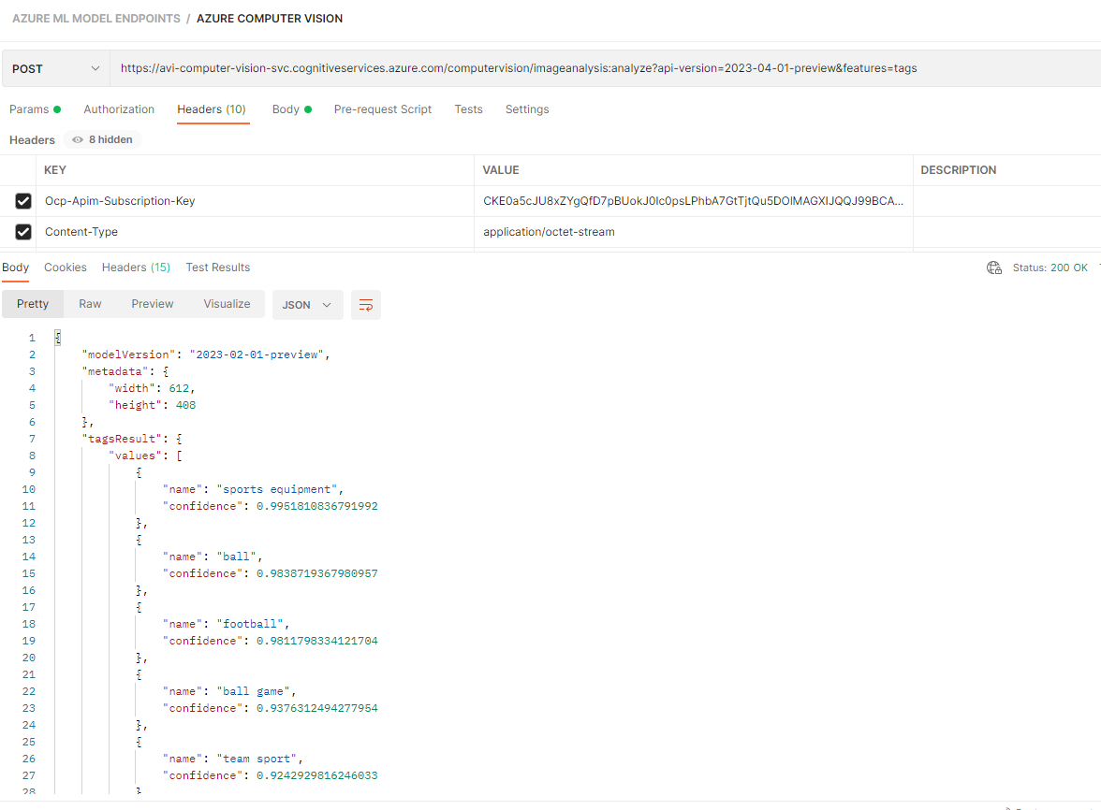

## CUSTOM VISION SERVICE

|  |
| --- |
| * This is a service that allows us to build and deploy our own image identification models. * We can use our own labels to train the model. * We can use Custom Vision via the Custom Vision portal. Or we can use it from a programming language by using the available SDK or REST API. * The Custom Vision service will allow us to first train a model with our own set of images. We can label the images to train the model. |

### SETTING UP CUSTOM VISION SERVICE

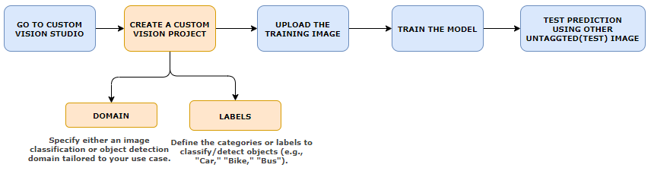

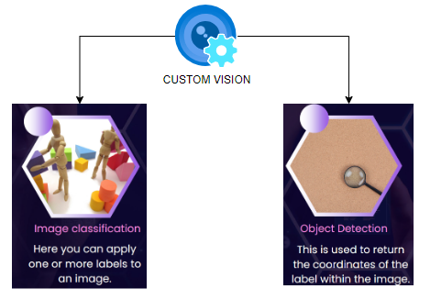

### CREATING A CUSTOM VISION SERVICE

* In the custom vision service - we first train a model based on images and then we can use it to predict right values based on images itself

|  |  |
| --- | --- |
|  |  |

* The custom vision deployment creates 2 resources

|  |  |
| --- | --- |
| [avicustomvisionsvc](https://portal.azure.com/#@absinhoutlook.onmicrosoft.com/resource/subscriptions/334f7b54-f838-4254-9c73-9679d75f8950/resourceGroups/ml-rg/providers/Microsoft.CognitiveServices/accounts/avicustomvisionsvc) | For Training |
| [avicustomvisionsvc-Prediction](https://portal.azure.com/#@absinhoutlook.onmicrosoft.com/resource/subscriptions/334f7b54-f838-4254-9c73-9679d75f8950/resourceGroups/ml-rg/providers/Microsoft.CognitiveServices/accounts/avicustomvisionsvc-Prediction) | For Prediction |

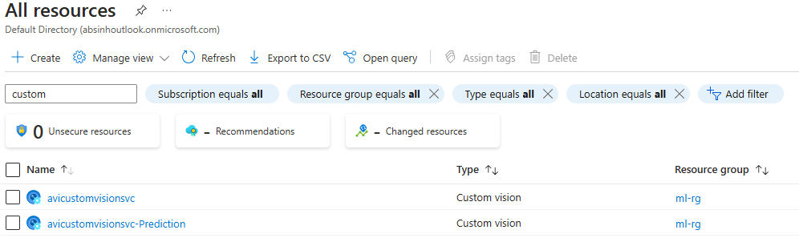

### CUSTOM VISION PORTAL

* Navigate to Custom Vision Portal : <https://www.customvision.ai/>
* Create a new Project. The project can 2 types
  + Classification: Classify image based on training data
  + Object Detection: To detect object within the image

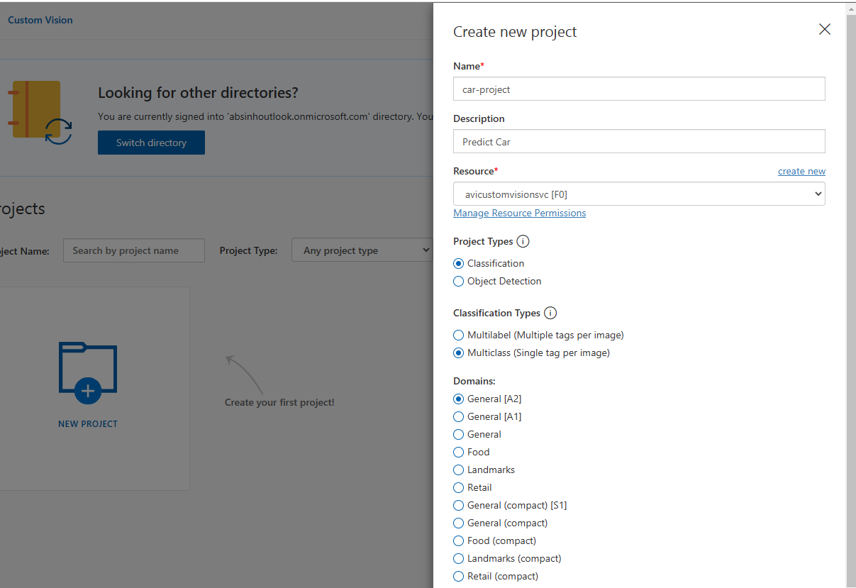

* In the below example - lets create “Classification” Project type and Classification Types 🡪 Multiclass 🡺 Then Create Project
* Add Image to train the Model (We will take example of different cars)

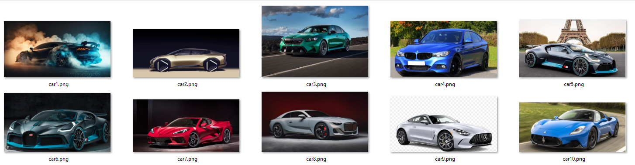

#### ADD/ UPLOAD IMAGES

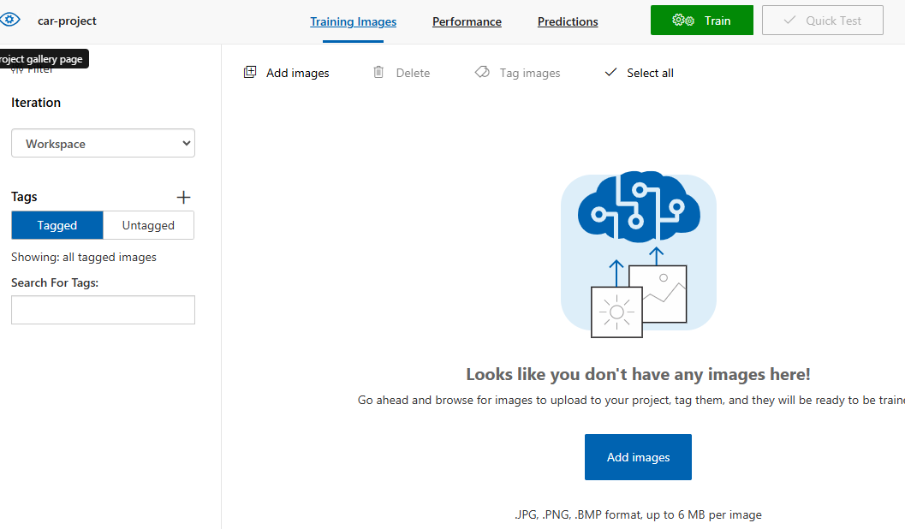

#### ADD TAG TO IMAGE

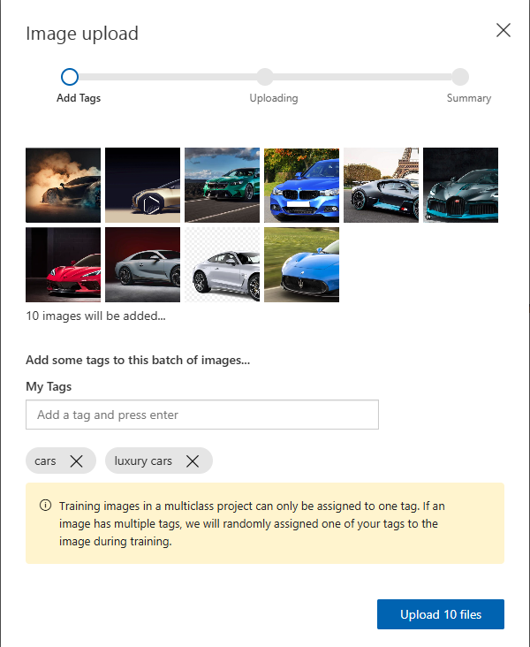

#### TRAIN THE MODEL BASED ON UPLOADED IMAGES

* Train the model based on uploaded image

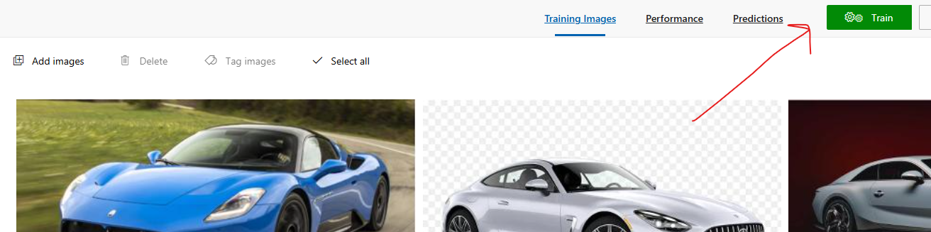

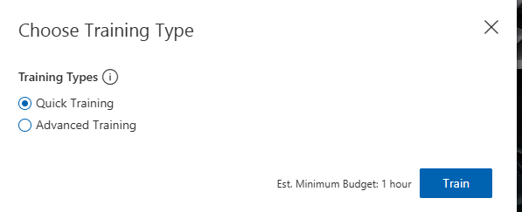

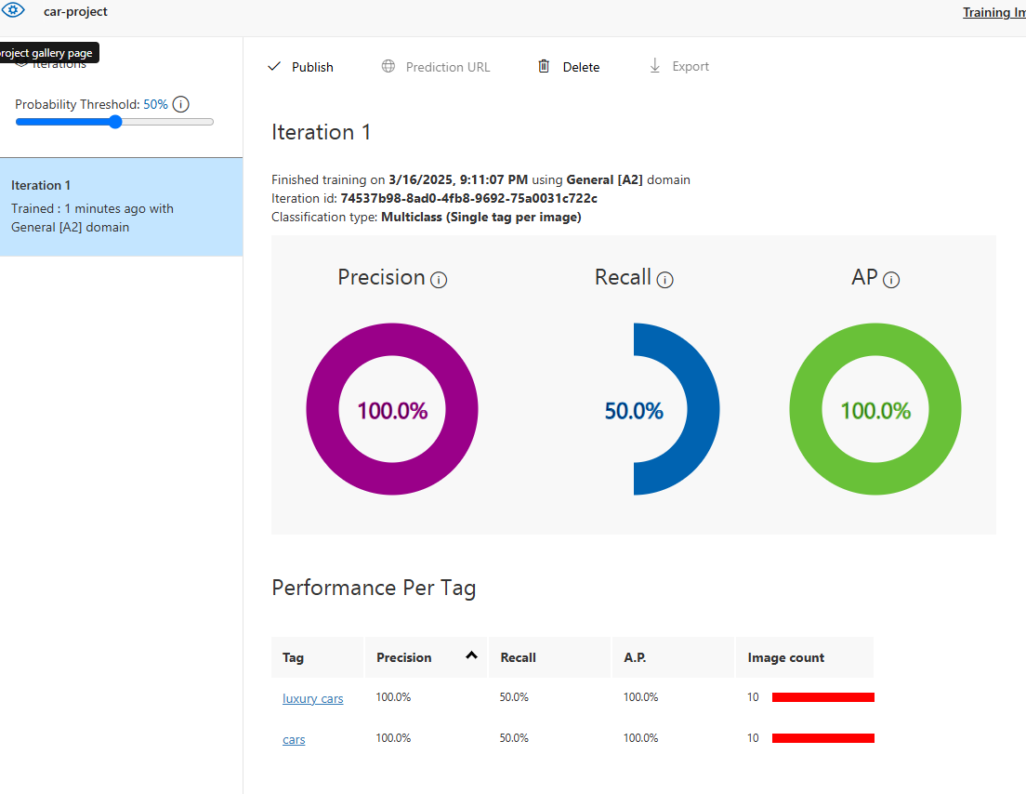

#### PUBLISH THE MODEL

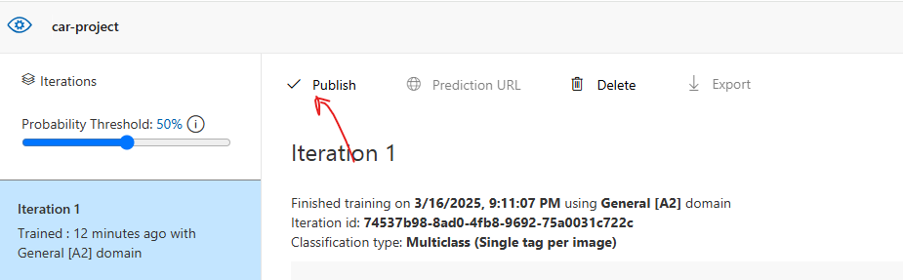

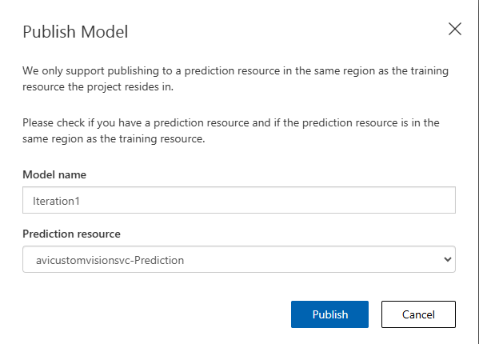

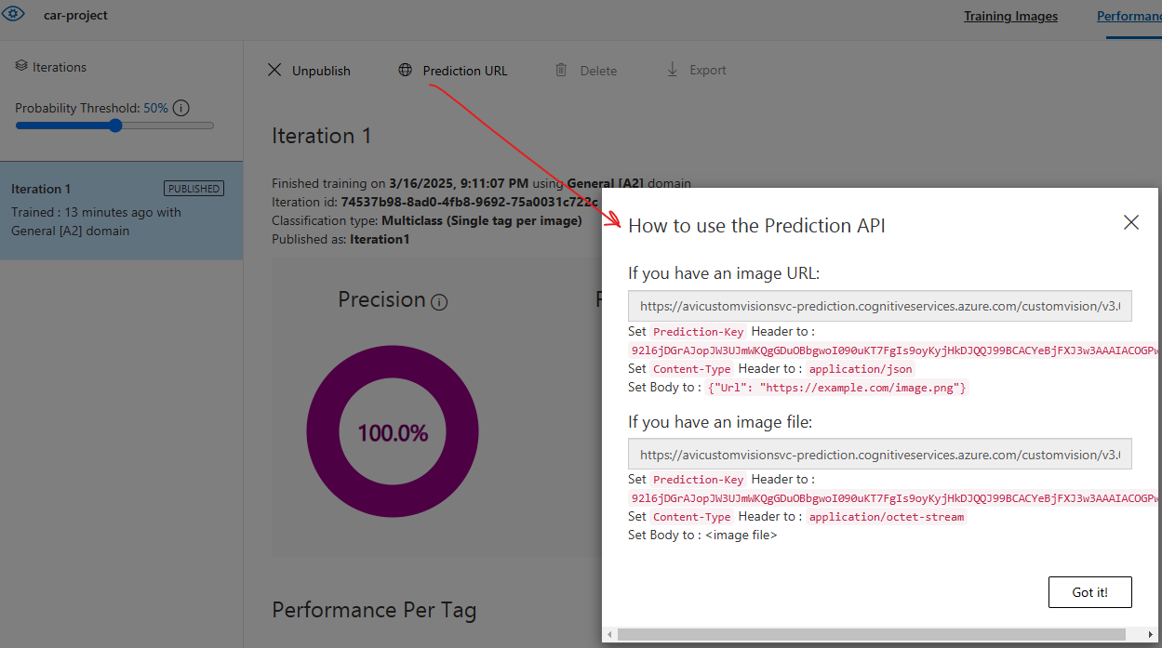

#### RUN THE TEST

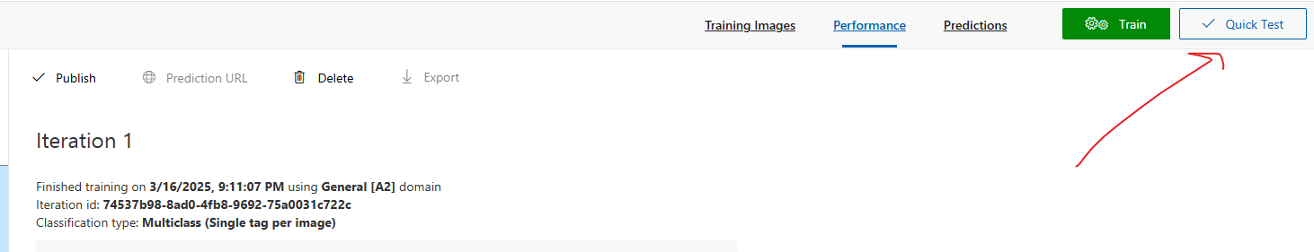

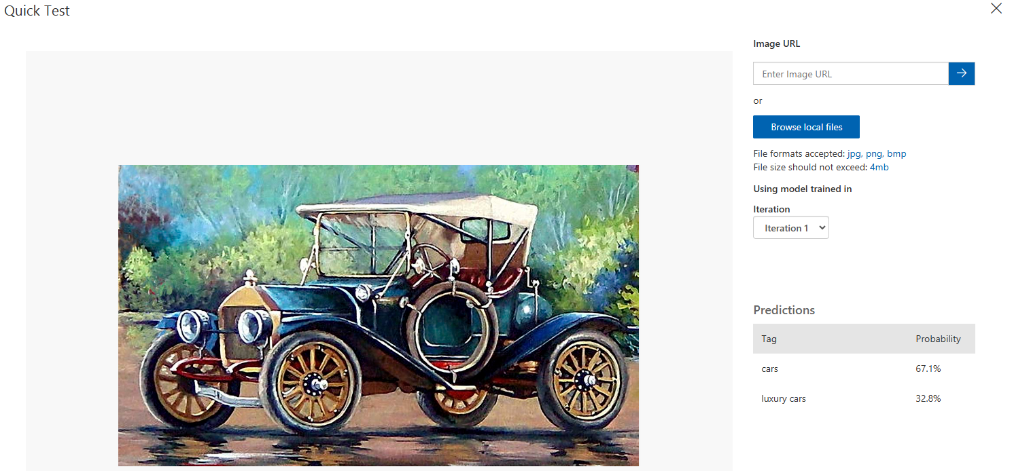

## FACE SERVICE

* This is a service that allows us to work with human faces within images.
* There are also some certain attributes that we can get about the face - Accessories - whether the human is wearing glasses, mask.
* **Face Recognition**
  + We can create a PersonGroup object that holds human faces.
  + We can then identify a particular face from the PersonGroup object.
* We can also use the Verify API to verify if a face and a Person object is the same.

### CREATING FACE API SERVICE

|  |  |
| --- | --- |
|  |  |

#### FEATURES IN FACE SERVICE

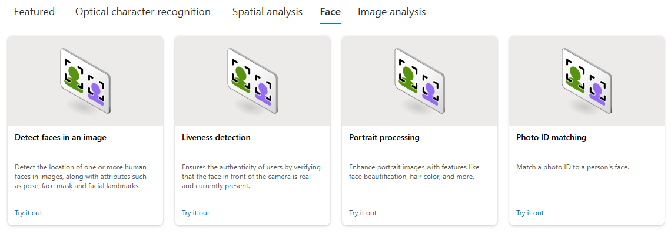

#### FEATURE - DETECT FACES IN IMAGE

|  |  |
| --- | --- |
|  | * This feature can detect faces from the image |

* Select the Resource and Subscription 🡪 Confirm
* Select / Browse the image to analyze

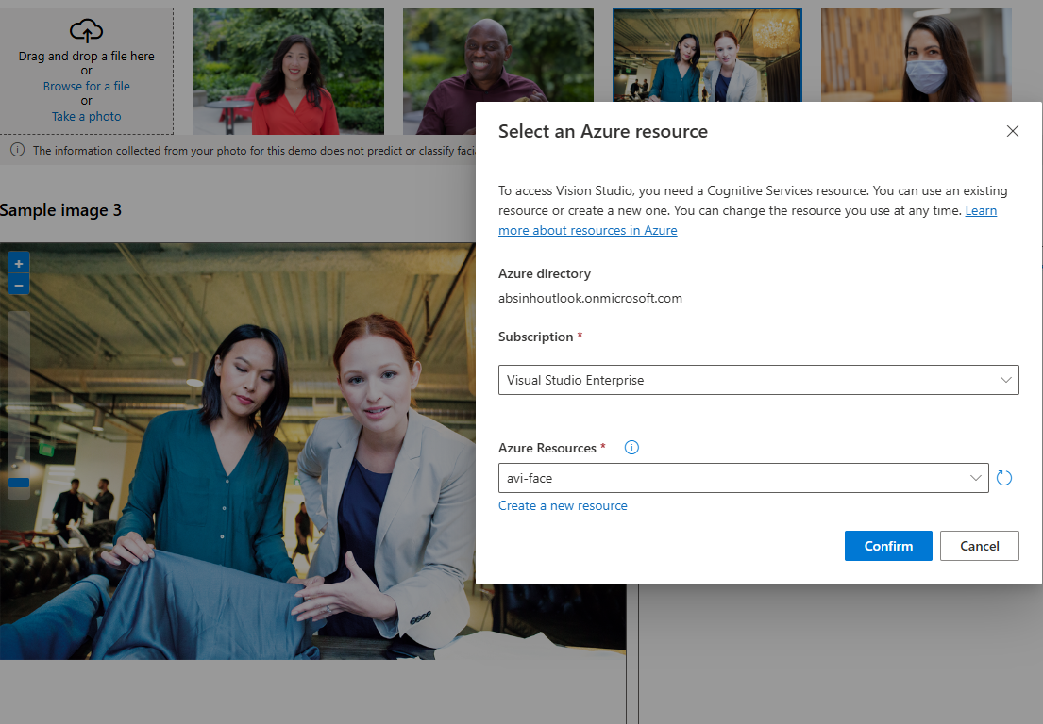

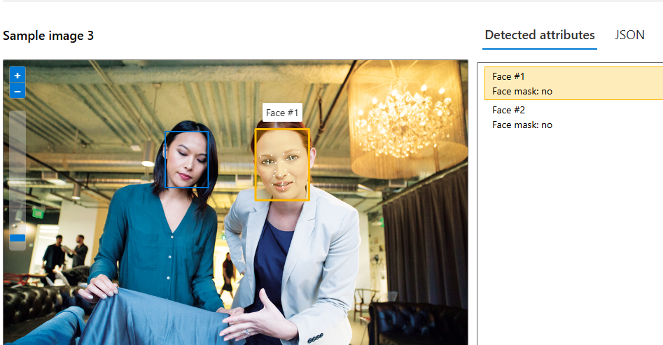

* The JSON data shows the attributes of the face in the image

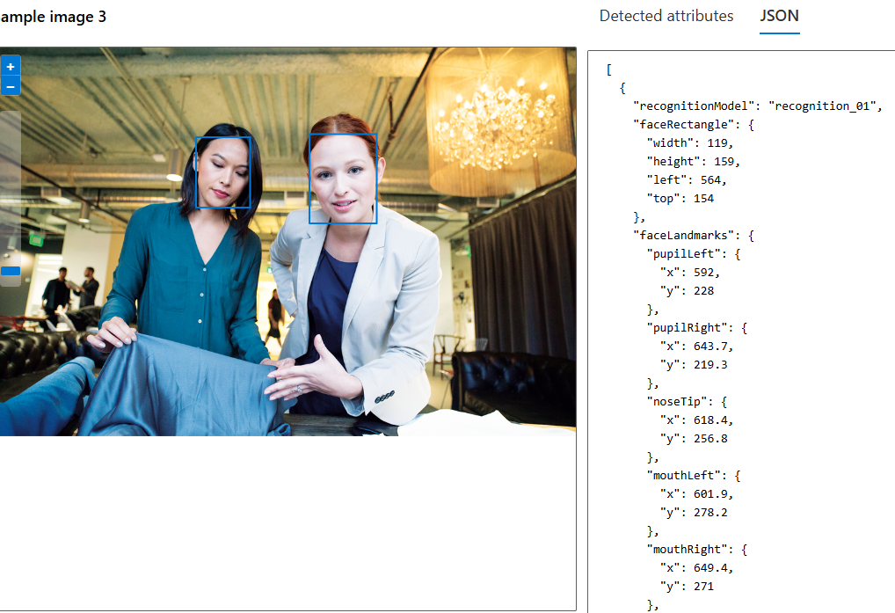

### CALLING FACE API SERVICE USING POSTMAN

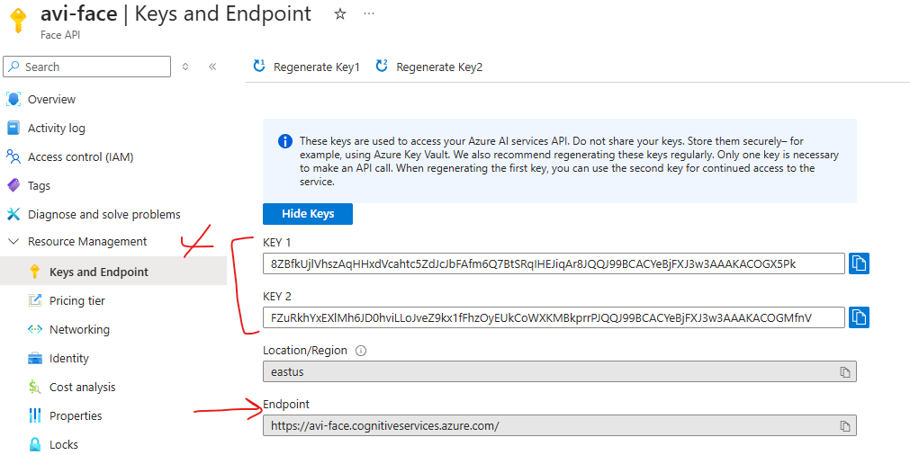

* Documentation : <https://learn.microsoft.com/en-us/rest/api/face/face-detection-operations/detect?view=rest-face-v1.2-preview.1&tabs=HTTP>

#### REQUEST

* REQUEST URL: <https://avi-face.cognitiveservices.azure.com/face/v1.2-preview.1/detect?_overload=detect&detectionModel=detection_01&recognitionModel=recognition_03&returnFaceAttributes=glasses,headPose,occlusion,accessories,blur,exposure,noise,qualityForRecognition&returnFaceLandmarks=True>
* **HEADERS**

|  |  |
| --- | --- |
| **Ocp-Apim-Subscription-Key** | Mention either of the key |
| **Content-Type** | application/octet-stream |

* **BODY**

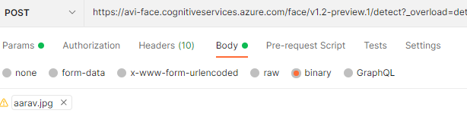

**EXAMPLE: POSTMAN**

QUERY STRINGS

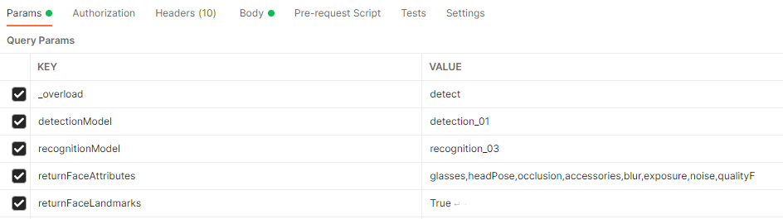

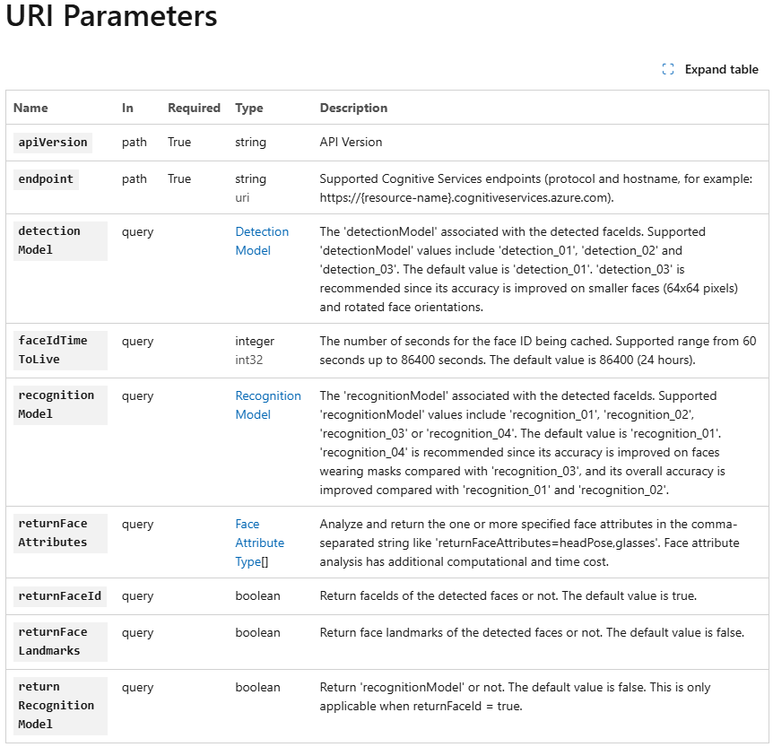

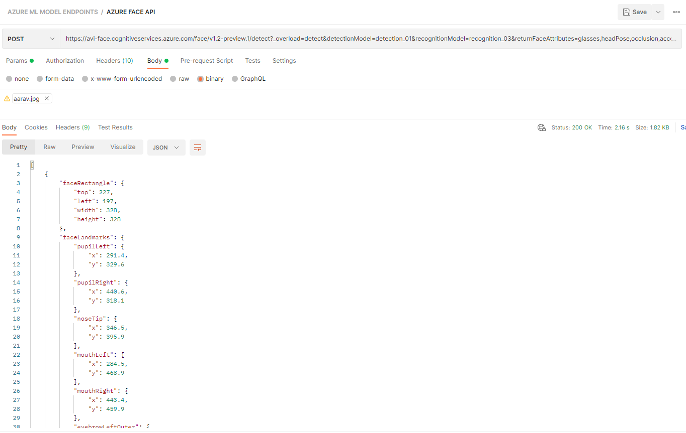

## OTHER FACE API FEATURES

* Documentation : <https://learn.microsoft.com/en-us/azure/ai-services/computer-vision/overview-identity>

# AZURE AI DOCUMENT INTELLIGENCE SERVICE

* Azure AI Document Intelligence is a cloud-based Azure service designed to process and extract data from documents.
* This service includes prebuilt machine learning models to extract specific information from common document types, such as:
  + Invoices: Extract details like customer name and invoice amount.
  + Bank Statements.
  + Contracts.
  + Credit Card Statements.
  + Tax Forms.
* It enables applications to automate the extraction of key details from documents, enhancing efficiency (e.g., linking invoice information to customer profiles).
* In addition to prebuilt models, users can create their own custom models tailored to specific document types and business needs

## CREATING A DOCUMENT INTERLLIGENCE SERVICE

|  |  |
| --- | --- |
|  |  |

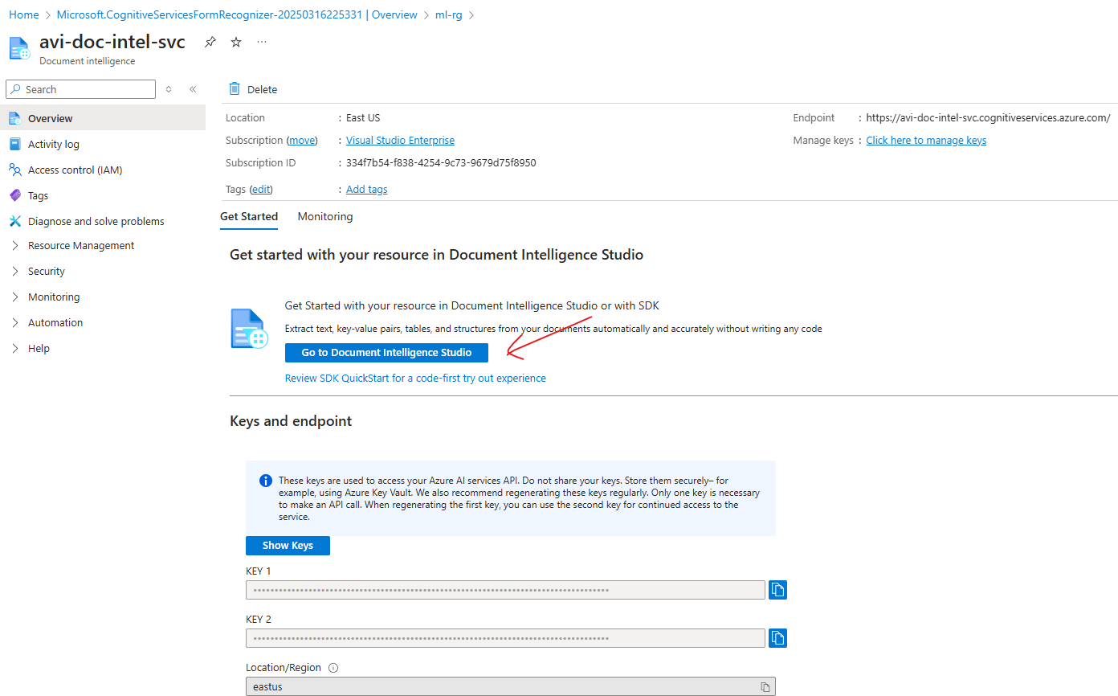

## DOCUMENT INTELLIGENCE STUDIO

* URL: <https://documentintelligence.ai.azure.com/studio/>

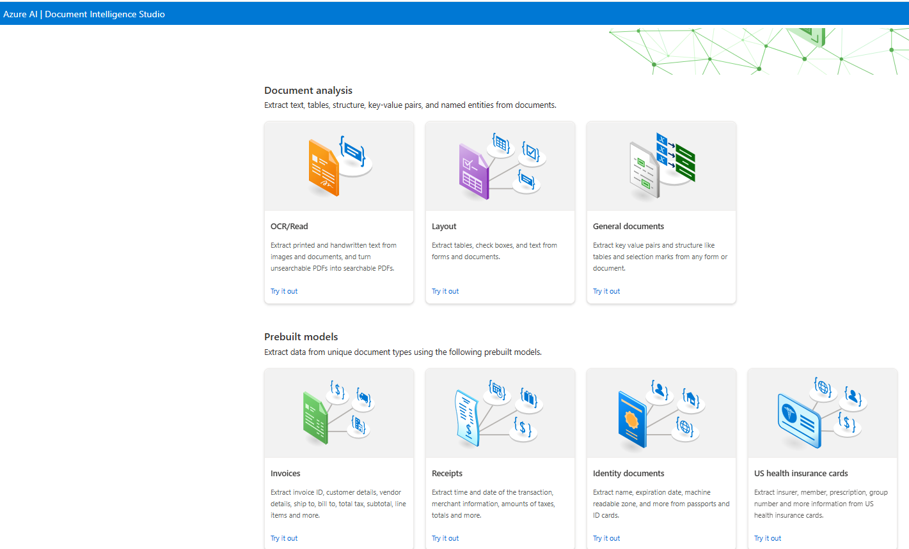

Let’s use the Invoices Prebuilt model and use the existing invoice

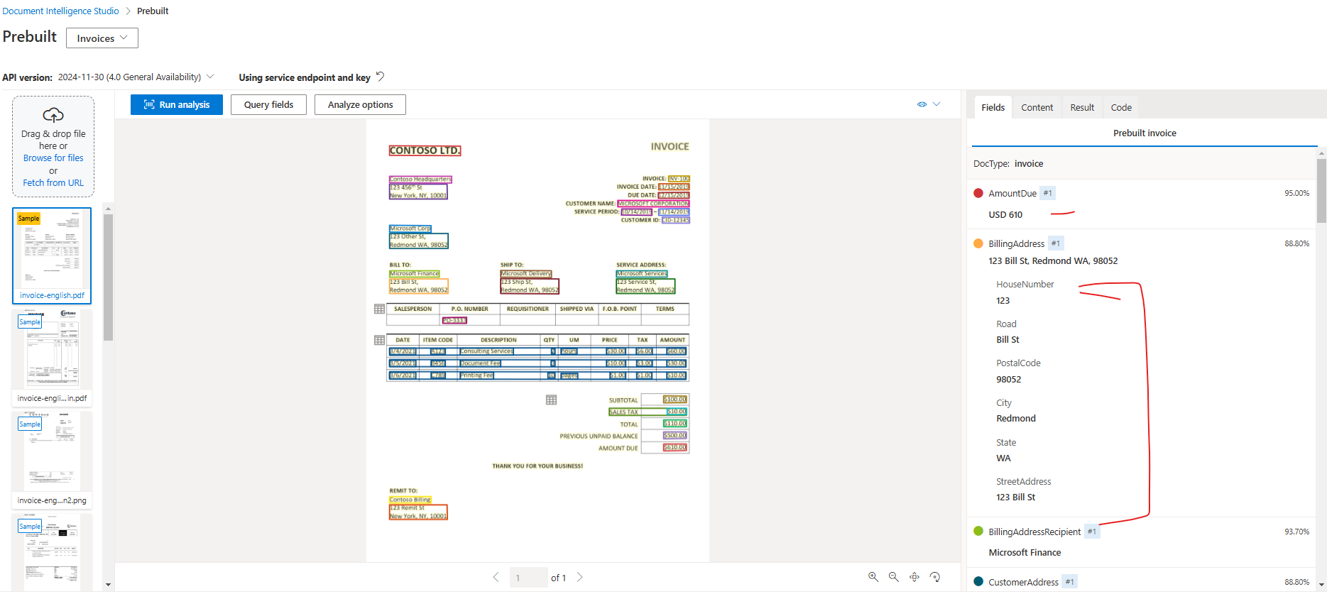

CUSTOM INVOICE

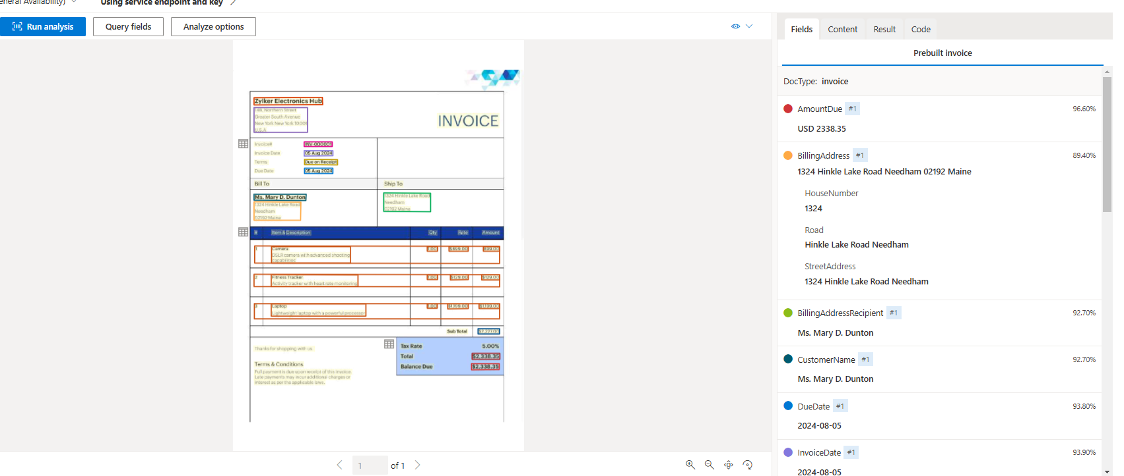

# AZURE AI FOUNDRY

# NATURAL LANGUAGE PROCESSING

## SERVICES FOR NLP IN AZURE

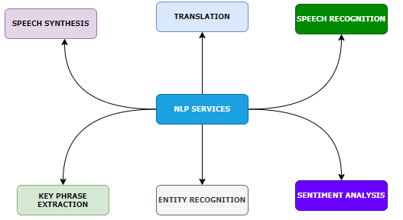

|  |  |  |
| --- | --- | --- |
|  | **DEFINATION & PURPOSE** | **AZURE SERVICE & USE CASE** |
| **KEY PHRASE EXTRACTION** | * **Definition**: Extract significant and relevant phrases or terms from a piece of text. * **Purpose**: Summarize text by identifying the most important information. | * **AZURE SERVICE**: Azure *Azure Text Analytics*: Automatically extracts key phrases to summarize documents, emails, or articles. * Use Case:   + Extracting main points from customer feedback or reports.   + Summarizing documentation. |
| **ENTITY RECOGNITION** | * **Definition**: Identify specific entities in text, such as names, dates, locations, organizations, etc. * **Purpose**: Extract structured information from unstructured text. | * **AZURE SERVICE:** *Azure Text Analytics*: Offers Named Entity Recognition (NER), which identifies entities in text documents. * **USE CASE**:   + Detecting people or organizations in email data.   + Extracting scheduled dates from documents. |
| **SENTIMENT ANALYSIS** | * **Definition**: Determine the emotional tone of text (positive, neutral, or negative). * **Purpose**: Analyze how users feel about a product, service, or topic. | * **AZURE SERVICE**: *Azure Text Analytics*: Provides sentiment scores for text inputs. * **USE CASE**:   + Monitoring brand sentiment from social media or customer reviews.   + Identifying trends in feedback surveys. |
| **TRANSLATION** | * **Definition**: Translate text from one language to another. * **Purpose**: Break language barriers and enable communication between different language speakers. | * **AZURE SERVICE**: *Azure Translator*: Supports translation into 90+ languages and provides customizable models for domain-specific translations. * **USE CASE**:   + Multilingual customer service chatbots.   + Translating marketing material for global audiences. |
| **SPEECH RECOGNITION** | * **Definition**: Converts spoken language (audio) into transcribed text. * **Purpose**: Enable speech processing for applications like transcription services. | * **AZURE SERVICE**:*Azure Speech-to-Text*: Automatically transcribes speech into text in various languages and accents. * **USE CASE**:   + Real-time transcription of meetings or interviews.   + Automated voice capture for note-taking. |
| **SPEECH SYNTHESIS** | * **Definition**: Converts text-based content into synthetic human-like speech. * **Purpose**: Enable communication from machines using natural-sounding speech. | * **AZURE SERVICE**:*Azure Text-to-Speech*: Offers natural-sounding speech synthesis and custom voice models. * **USE CASE**:   + Text-to-speech conversions for virtual assistants and chatbots.   + Interactive announcements, such as in public service |

## AZURE LANGUAGE SERVICE

### CREATING LANGUAGE SERVICE

|  |  |
| --- | --- |
|  | * Default features available with the language service |

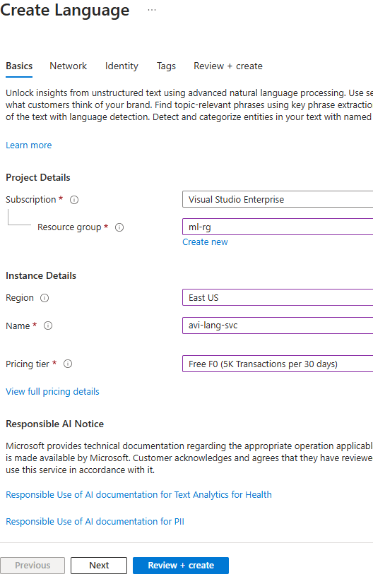

#### LAUNCH LANGUAGE SERVICE

* URL : <https://language.cognitive.azure.com/home>

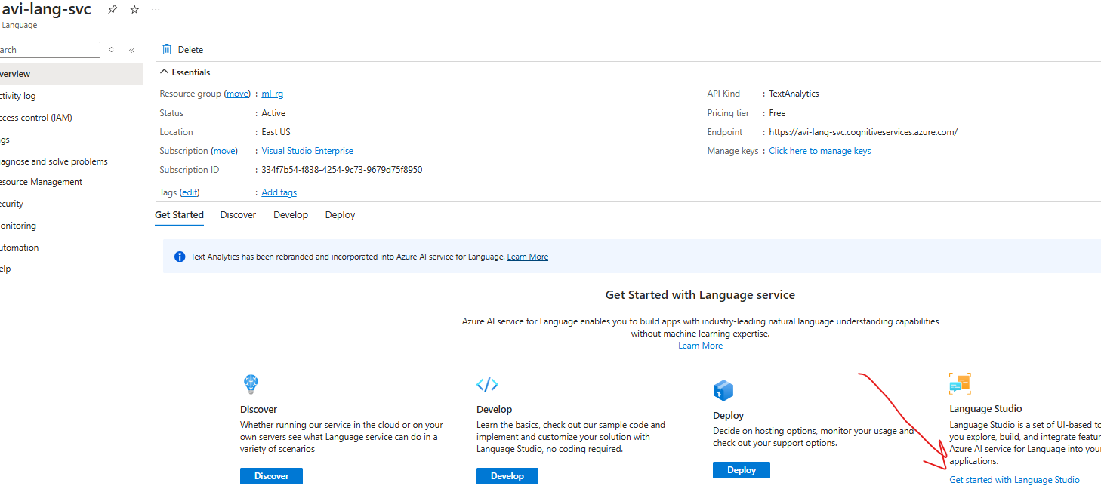

## KEY FEATURES

### KEY PHRASE EXTRACTION

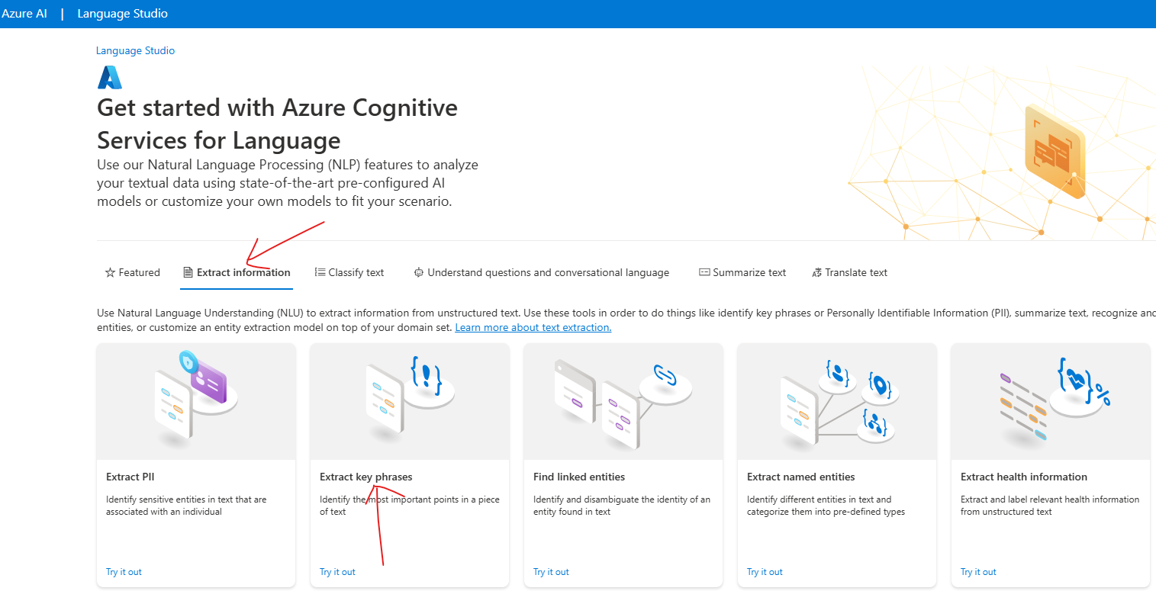

## AZURE TRANSLATOR SERVICE

## AZURE SPEECH SERVICE